Economic Transition: National Development
How can countries be classified according to their level of economic development?
There is no universally agreed method to classify countries according to their level of economic development. Measures of development, such as Gross Domestic Product (GDP), Gross National Income (GNI), the Human Development Index (HDI), the Physical Quality of Life Index (PQLI) are often used as the basis for determining global groupings of countries with similar levels of economic (and social) development.
1950s­1980s (Three Groups):
First World (Developed World) - North America, Western Europe, Japan, Australia, New Zealand
Second World (State­-controlled Communist Countries) - Former USSR, Eastern Europe
Third World (Developing World) - Africa, Latin America, much of Asia
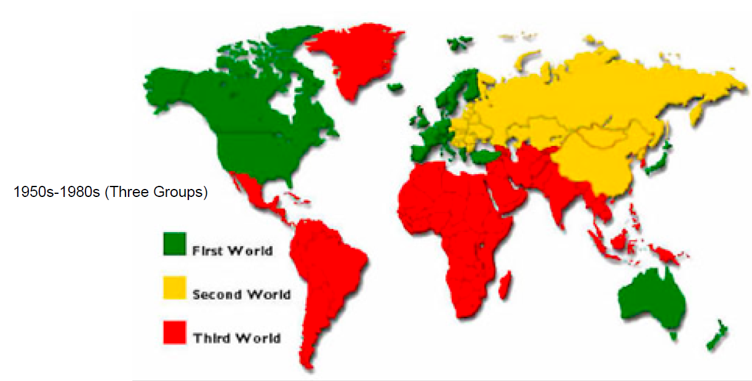
1980s­1990s (Two Groups):
In 1980, the German Chancellor, Willy Brandt, proposed a line through the world as a visual depiction of the North-South divide. The line, also known as the Brandt line, encircles the world at a latitude of approximately 30°N, passing between North and Central America, north of Africa and the Middle East, and climbing north over China and Mongolia. However, it then dips sharply southwards in the Western Pacific to include Australia and New Zealand above the line. The North-South divide separates the world into:
Developed World (MEDCs of the Rich North)
Developing World (LEDCs of the Poor South)
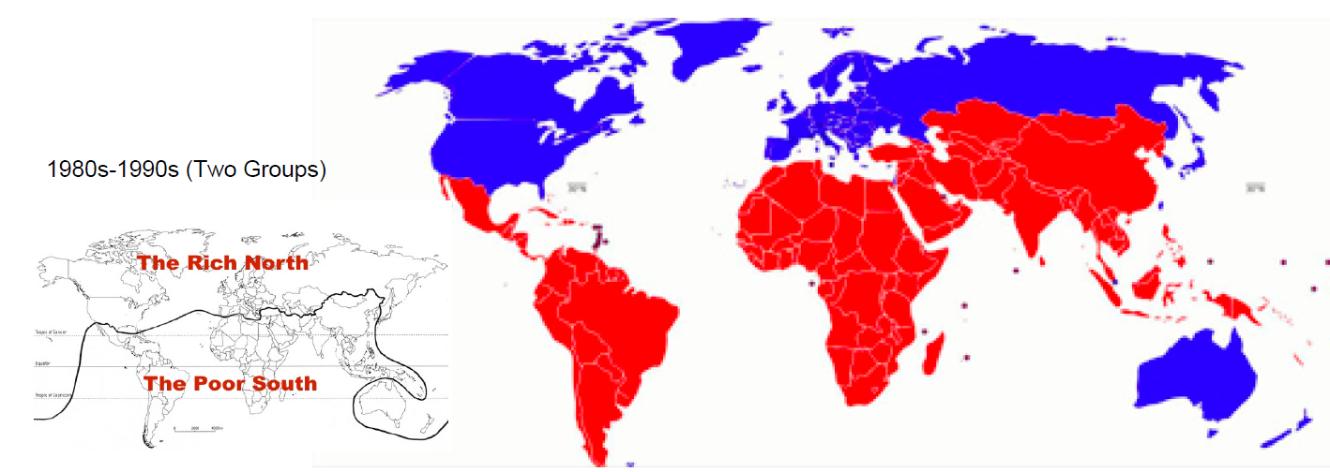
Critics of the North-South classification point out a number of geographical anomalies. Following the dissolution of the USSR in late-1991, many of its constituent countries were reclassified as developing, despite being in the ‘Rich North’. Furthermore, the rapidly industrialising ‘Asian Tigers’, such as South Korea and Singapore, continued to be shown in the ‘Poor South’, despite possessing economies more typical of the world’s developed nations.
Essentially, the main problem with a two group classification is that it is too simplistic. As countries develop, they pass from one condition to another. The transition is gradual, with no abrupt points of change. The development process, with countries at various stages of development, is referred to as the development continuum. This recognises that there is no clear cut-off point between rich and poor. An example of a recent classification is shown below.
2000s­2010s (More Groups although lots of variations in the names and specific criteria):
G7/(G8) Countries - USA, Japan, Germany, UK, France, Italy, Canada, (Russia)
Advanced Economies / Developed Countries (MEDCs) - Spain, Denmark, Australia, New Zealand etc.
Oil-Rich Countries / Organisation of the Petroleum Exporting Countries (OPEC) - Saudi Arabia, Kuwait, UAE etc.
Newly Industrialised Countries (NICs) - Singapore, South Korea, Taiwan, Brazil etc. (countries with approximately 30-45 years of industrialisation)
Former Soviet Countries (FSCs) / Centrally Planned Economies - Hungary, Poland, Romania, Latvia etc.
Recently Industrialised Countries (RICs) - China, India, Vietnam etc. (countries with approximately 10-25 years of industrialisation)
Less Developed Countries (LEDCs) / Developing Countries - Kenya, Ghana, Zimbabwe, Pakistan, Bolivia etc.
Least Developed Countries (LDCs) and Heavily Indebted Poor Countries (HIPCs) - DR Congo, Ethiopia, Mozambique, Somalia, Afghanistan, Nepal etc.
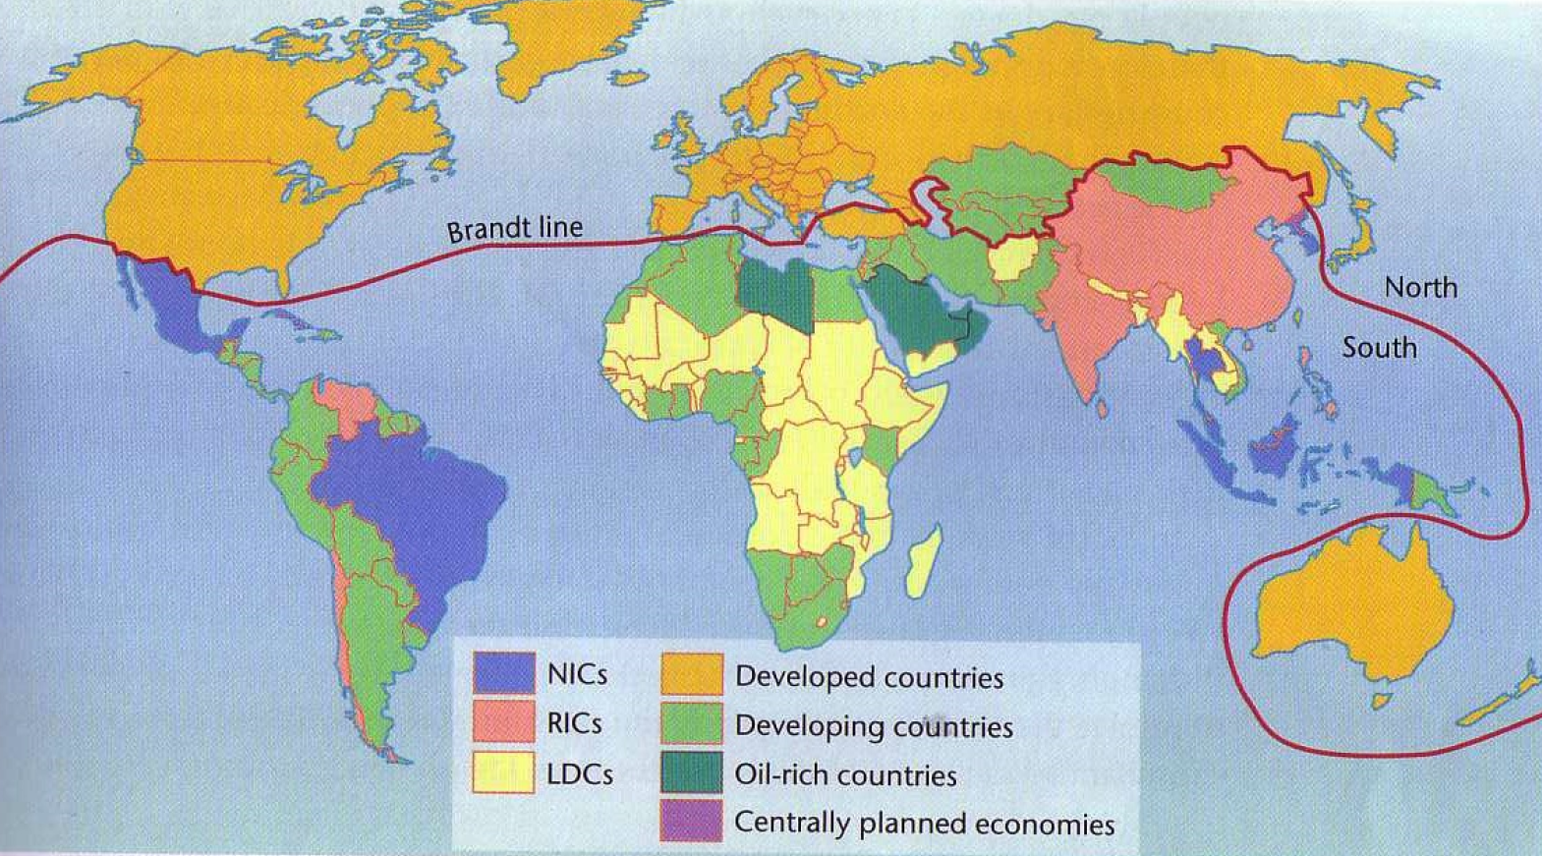

Any such classification is fraught with difficulties. Firstly, there are different ways to measure development e.g. GDP, GNI and HDI, each of which can be calculated in multiple ways. Secondly, even within each global group, countries will display a range of levels of economic, social and political development. Thirdly, some countries may develop very quickly or their development may be reversed due to internal or external shocks, so the make-up of the global groups is constantly shifting. The development continuum also exists within countries, since clear regional and local (such as urban-rural) differences often emerge.
World Bank Classification (Four Groups)
The World Bank uses GNI per person, calculated using the World Bank Atlas method, to classify the world’s nations. As of July 2015, the following classification was in use.
High-income economies (HICs) - $12,736 or more
Upper-middle-income economies (MICs) - $4,126 to $12,735
Lower-middle-income economies (MICs) - $1,046 to $4,125
Low-income economies (LICs) - $1,045 or less
Using the World Bank classification, and updated GNI figures for 2014, a number of countries moved into new income groups. Bangladesh, Kenya, Myanmar and Tajikistan moved from low-income to lower-middle-income, Mongolia and Paraguay moved from lower-middle-income to upper-middle-income, while Argentina, Hungary, Seychelles and Venezuela moved from upper-middle-income to high-income. The only country in reverse was South Sudan, which only became a nation in 2011. It moved from lower-middle-income to low-income, a consequence of the armed conflict in the country which broke out in late-2013.
IMF Classification: (Three Groups)
The International Monetary Fund uses several criteria to classify the world’s nations into AC, EDC or LIDC countries. These criteria include per capita income level, degree of integration into the global financial system and export diversification (so oil-rich countries that have high per capita GDP would not make the advanced countries classification because around 70% of their exports are oil).
Advanced Countries (AC) Emerging and Developing Countries (EDC) Low-Income Developing Countries (LIDC)
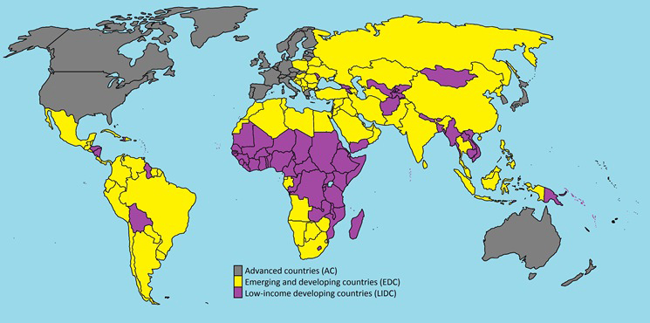
United Nations Classification (Four Groups)
The UN prefers to use HDI to classify the world’s nations. Its 2015 Human Development Report (covering 188 countries and almost 99% of the world population) used the following classification.
Very high human development - 0.800 and above
High human development - 0.700 to 0.799
Medium human development - 0.550 to 0.699
Low human development - below 0.550
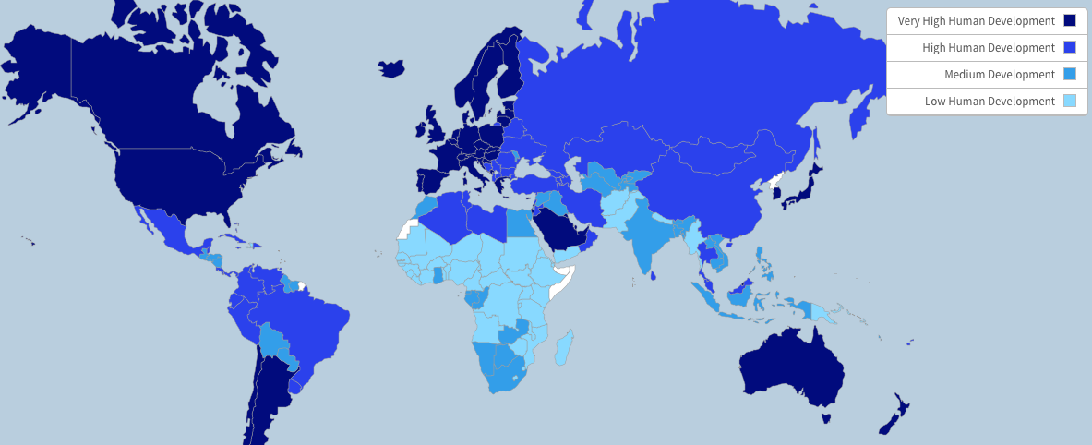
Since 1990, the number of countries in the low human development category has fallen from 62 to 43, representing a drop in population numbers from 3 to 1 billion. The number of countries in the high or very high human development categories has risen from 47 to 84, representing a tripling in population numbers to 3.6 billion.
Norway came out in the UN’s latest report as the highest ranked country (1st) with an HDI score of 0.944. Niger is the lowest ranked country (188th) with an HDI score of 0.348.
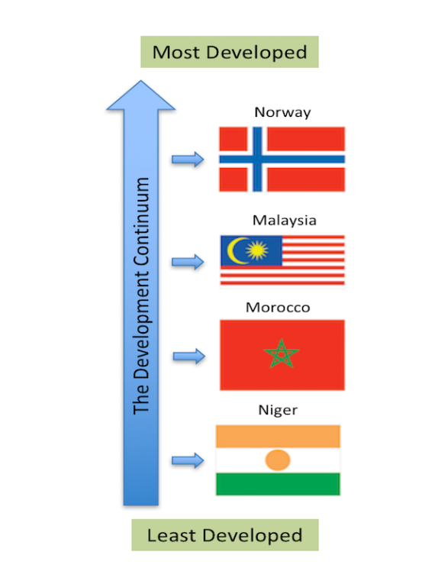
Tasks:
- Explain the limitations of the north-south divide line
- Discuss the advantages and disadvantages of using multiple global groupings (e.g. 7+) to show countries with similar levels of development
- The UN prefers to use HDI to classify a country’s development rather than GDP or GNI. Explain the advantages of using HDI over GDP or GNI
- Describe the global pattern of human development based on HDI. Your answer should clearly identify spatial patterns between and within continents, including clusters and anomalies
- Suggest at least 10 factors that might account for differences in human development between countries (produce a list of these factors)
- Define the following key terms: gross domestic product, gross national income, human development index, development continuum, development gap, quality of life, standard of living, internal/external shocks, NICs, RICs, BRICS
Changes Associated with Development:
Development brings many changes to countries - economic, social, demographic and political. In addition, countries that have progressed further along the development continuum often try to persuade countries that have made less progress to adopt these changes - an example of ‘soft power’. Occasionally, these changes may occur through military force or coercion - ‘hard power’.
Economic Changes:
- Employment shift - agriculture to manufacturing industry, and on to modern service activities e.g. financial services
- Manufacturing moves up the value chain - more technologically advanced i.e. hi-tech
- Expansion of international trade - both exports and imports
- Income inequality may well increase
Social & Demographic Changes:
- Educational improvement - more young people complete secondary and tertiary (university) education
- Narrowing of gender inequality - workforce more gender-balanced
- Health improvements - falling infant, child and adult mortality rates
- Population becomes more urban-based - housing improves (eventually)
- Exposure to modern media increases - TV, internet, films
- Diets, lifestyles and values linked to consumerism - society becomes more secular
- Ageing population - increasing life expectancy and falling fertility / birth rates
- Population structure becomes typical of stages 4 & 5 on the demographic transition model
Political Changes:
- Move to greater democracy and political freedom - free elections, free speech
- Pressure for improved governance - less corruption and favouritism
- Recognition of the rights of minority groups

