Global Patterns of and Inequalities in Trade Flows
International trade has experienced huge growth over the last 50-60 years, but in most cases it is the HICs that have benefited the most. The major change over the last 20-25 years has been the rapid economic growth of some LICs, such as China, India, and Brazil, helping to transform them into MICs (also known as emerging economies or NICs) that are doing very well out of international trade. The LICs with mainly an agricultural and raw material base are the ones that continue to struggle with international trade.
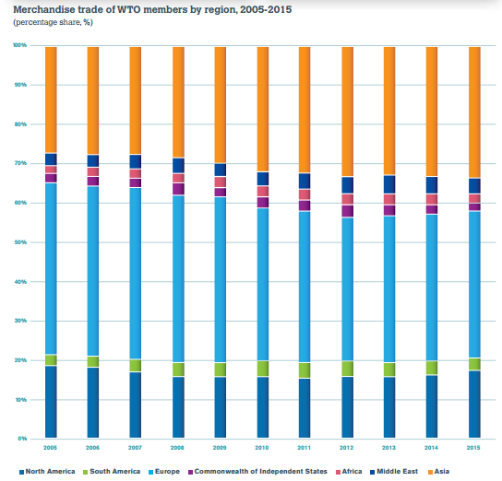
NORTH AMERICA
EUROPE
ASIA
AFRICA
Asia, Europe and North America have accounted for 88% of the total merchandise trade of WTO members over the past ten years. Africa has accounted for less than 3%.
Africa: A Continent Illustrating Global Inequalities in Trade Flows…
- Africa’s trade is overly dependent on a narrow range of primary products. Although exports of agriculture and manufacturing have been growing, fuels and mining products constituted 66% of Africa’s total exports in 2010.
- Many African countries have difficulties obtaining finance (loans) to help develop infrastructure and manufacturing plants. This means that even if they have raw materials for export, like iron ore, they cannot process it into steel products that could be sold for much higher prices.
- Many African countries face trade barriers when they try and export foodstuffs or minerals overseas (especially to the EU Trading Bloc).
- Many African countries are also burdened with massive debt, making it difficult to develop stronger and more competitive industries.
- Recent growth of world trade with Africa has been mainly for raw materials e.g. gold, iron ore, coltan (used in smart phones). Although this does bring money into these countries, exports are nearly always unprocessed and low in value (if African countries turned iron ore into steel they would add much more value to their exports).
- A number of African countries exhibit one-commodity dependency or two-commodity dependency (see map below) which is risky from a balance of trade perspective, and makes it unlikely that their exports will grow over time
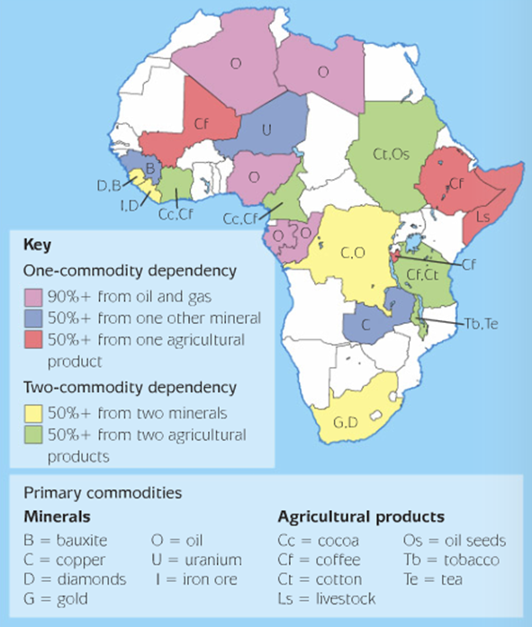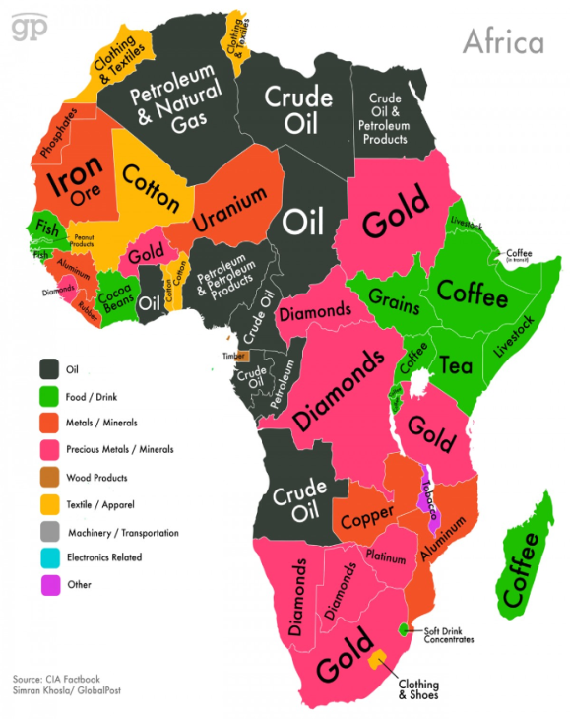
Alternative Map of African Economies & Their Major Trade Products

Tasks:
- Explain why Europe’s share of world trade is much greater than North America’s share.
- Explain Africa’s very low share of world trade (both by quantity and value).
- Outline and explain the problems of one-commodity or two-commodity dependency.
- Research the growth in trade of one MIC country e.g. China, India or Brazil. Compile a summary report (text, data, graphs, maps) on the changes in the value and types of exports and imports for your chosen country, as well as the country’s major trading partners. Explain concisely the key reasons for the growth in this country’s trade.

