The Challenge of Global Poverty

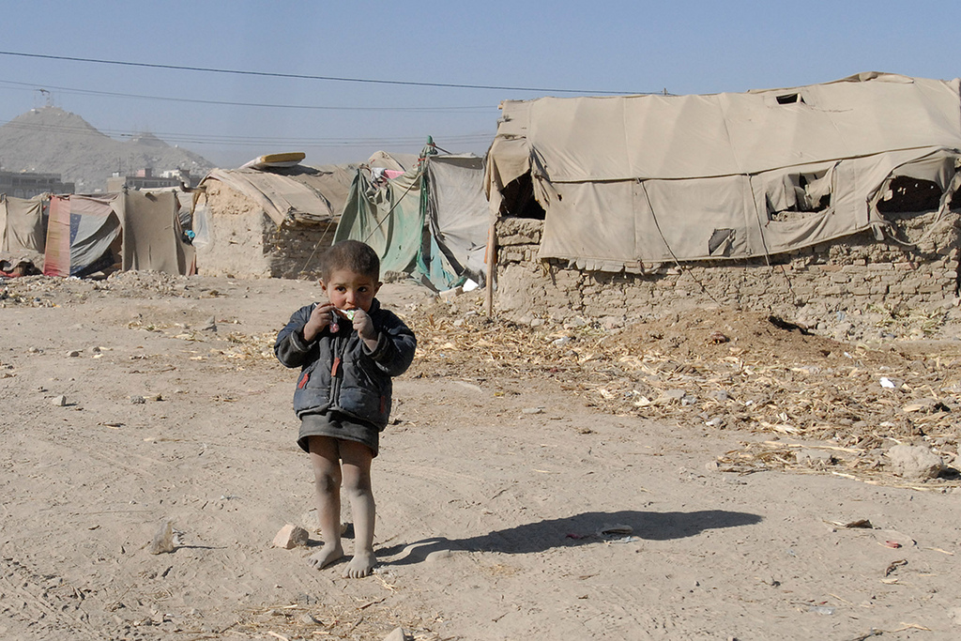

Characteristics & Measurement of Poverty

- Define the terms ‘extreme poverty’, ‘moderate poverty’ and ‘relative poverty’.
- Describe what poverty looks like in the real world.
- What is ‘HDI’? Suggest why it is seen by many as being a better indicator of poverty and development than GDP or GNP/GNI.

Distribution & Extent of Poverty

Study the cartoon below:

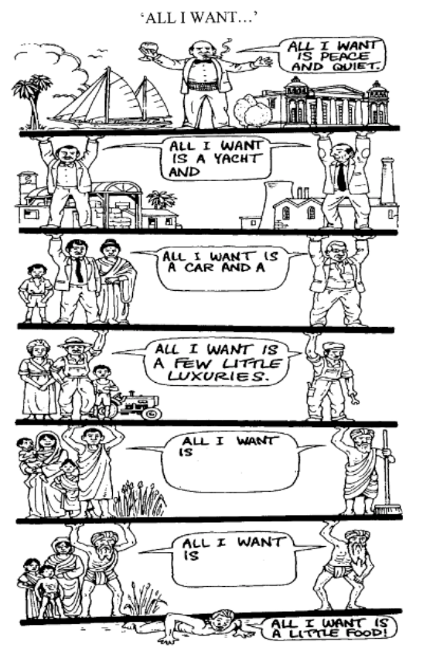
- Where is the extreme poverty and relative poverty?
- What is the main message being shown?

Study the map and graph below:

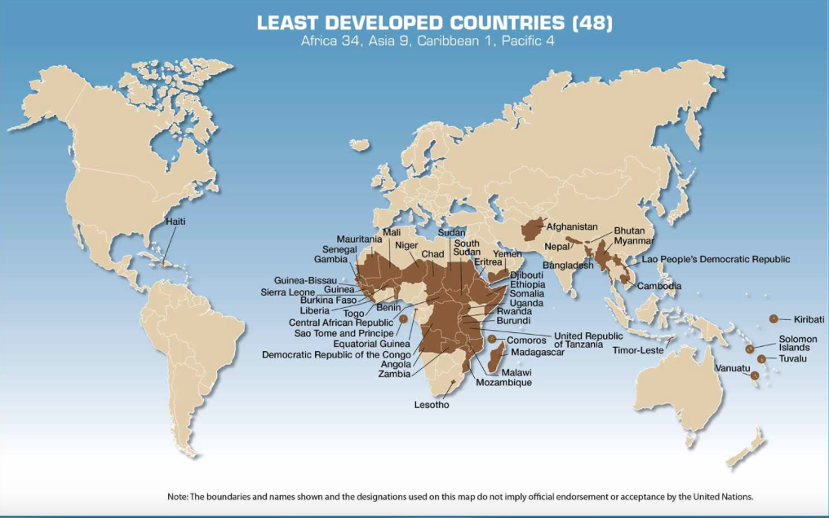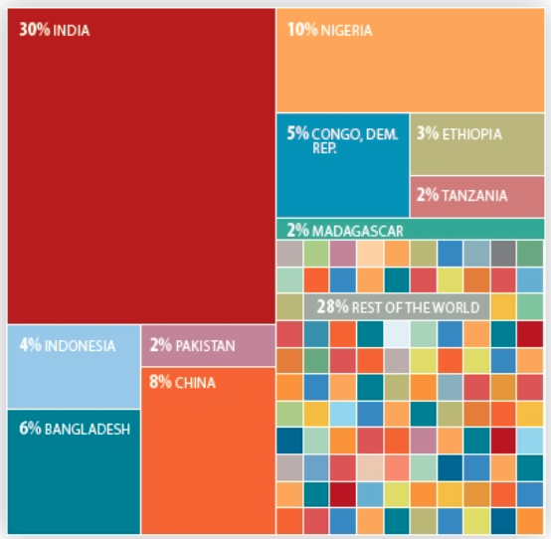

- Using the map, graph and your own knowledge, describe the global distribution of poverty, with particular reference to those countries and regions with large numbers or percentages of people living in extreme poverty.
- Suggest why some parts of Asia have seen large falls in poverty while others have seen large increases.

Causes of Poverty

- Add detail to the table below (and try to include specific examples) to explain and illustrate the various factors that contribute to poverty. You can change the terms in the first column should you wish.

Environmental Causes
Physical Geography
Natural Disasters
?????
Economic Causes
Unfair Trade
Debt
?????
Social Causes
Health
Clean Water
Food Availability
?????
Political Causes
Corrupt Governments
Civil & International Wars
?????

- ‘The causes of poverty are many, interrelated and often very complex’. To what extent do you agree and why?
- Describe and explain the cycle of poverty.

Addressing Poverty on a Global Scale

- Complete the table below to illustrate how international agencies are addressing poverty around the world, along with comments on the effectiveness of their work.

Name of attempt | What it involves | Scale and location(s) | Positive and/or negative comment (EVALUATION)
UN Millennium Declaration of 2000 (usually referred to as the Millennium Development Goals - MDGs) covering the period up to the end of 2015  2016 saw the UN adopt the new 2030 Agenda for Sustainable Development, with an even more ambitious set of goals, known as the Sustainable Development Goals (SDGs) or Global Goals | Global leaders committed their countries to help reduce extreme poverty and related causes/problems by the year 2015 through 8 Millennium Development Goals & 21 targets.  The UN contributes through the UN Development Programme (UNDP) and the UN Children’s Fund (UNICEF) but expects many other organisations and governments to work towards achieving the goals/targets. | Almost every country targeted, although the largest number in need are in the least developed countries of sub-Saharan Africa, Western, Central and Southern Asia.  Projects can range in scale from large to small e.g. investing in agricultural research (for high yielding varieties of crops) in Vietnam; interest-free loans for seeds and tools to farmers in Nigeria. | Not all targets are achievable, such as the target to ensure all boys and girls will be able to complete a full course of primary schooling.  Success has been uneven – African countries often less successful than Asia countries. Is this because the problems are greater and therefore harder to solve in Africa or because Africa is not receiving as much assistance as Asia?
The Global Fund to Fight AIDS, Tuberculosis and Malaria | UN member countries and the G8 countries agreed in 2002 to set up a ‘war chest’ of funds to fight the world’s three deadliest infectious diseases that account for 6 million deaths annually and contribute to both moderate and extreme poverty. The UK government has donated £1 billion to The Global Fund for the years 2014-2016.  Non-governmental supporters include (RED), Bill & Melinda Gates foundation, Coca-Cola & The United Methodist Church. The fund provides money to partner organisations in the affected countries. | Any country with a significant rate of infection for any of the three diseases is eligible. Over 140 countries have benefitted from the work of The Global Fund.  The Global Fund channels 82% of the international financing for TB, 50% for malaria, and 21% of the international financing against AIDS. It also funds the strengthening of health systems. | The Global Fund works with partner organisations in the affected countries as these are the local experts on how best to use the money.  By mid-2013 The Global Fund support has given antiretroviral therapy to 5.3 million people with AIDS, has tested and treated 11 million people for TB, and has distributed 340 million insecticide-treated nets to protect families against malaria.  Could more be done to help the victims of AIDS?
Millennium Promise (usually referred to as the Millennium Villages Project – MVP) | Co-founder was Dr Jeffrey Sachs, director of the Earth Institute at Columbia University. The project involves addressing the root causes of extreme poverty by targeted investment over 5 years in agriculture, education, health, infrastructure, gender equality, and business development until sustainable growth is achieved.  Partners include Agrium Inc (fertiliser), Sumitomo Chemical (mosquito nets), Ericsson, governments of UK, Japan & S. Korea, governments of the MVP’s host countries | Remote and largely rural communities in Africa have been targeted by the MVP.  There are 14 locations in 10 African countries at present which receive high-yield seeds, fertilizers, medicines, insecticide-treated bed nets, antiretroviral drugs, drinking wells, materials to build school rooms and clinics.  Children receive free school dinners. Mobile phones and internet connectivity are also key elements to remove economic isolation. | Half a million people across Africa are benefitting from the tools and resources needed to break the cycle of extreme poverty for good.  Millennium Promise was the first international non-governmental organisation committed to supporting the achievement of the MDGs through tangible results.  Is the cost of the programme, at $120 per person per year, too high?  Can the programme be up-scaled to larger size communities? Will it work in poor urban areas or other environments e.g. Himalayas, Andes?
World Bank & International Monetary Fund (IMF) | The Heavily Indebted Poor Countries (HIPC) are the 38 least developed countries with the greatest debt. The HIPC Initiative…
Oxfam or World Vision or another NGO

Bill & Melinda Gates Foundation

UK Department for International
Development (DFID)

Make Poverty History Campaign
(including Drop the Debt)

- Evaluate the progress in achieving the MDG goals and targets by the end of 2015. Refer to the degree of success in achieving at least 5 of the targets in your answer.

Poverty Case Studies

- Answer the tasks from any 2 of the following case studies:

- Bangladesh Tasks:

- What evidence shows its level of development?
- What factors keep many of its people poor?
- How much progress has been made with the MDGs?
- What makes its sustainable development challenging?

- Zimbabwe Tasks:

- What problems have the policies of land seizure and urban slum demolition created?
- What evidence suggests an improving situation?
- What makes its sustainable development challenging?
- Why is China interested in Zimbabwe?

- DR Congo Tasks:

- Why is infrastructure development so difficult?
- What was the evidence of corruption under the leadership of Mobutu Sésé Seko?
- Why did the country descend into civil war?
- What evidence suggests an improving situation?
- Why is China interested in DR Congo?

- Afghanistan Tasks:

- Why is infrastructure development so difficult?
- What factors keep many of its people poor?
- How much progress has been made with the MDGs?
- What makes its sustainable development challenging?
- Why is China interested in Afghanistan?

Beyond Poverty: The Development Continuum

- Define the term ‘development continuum’.

- What are the weaknesses of the ‘North-South’ method for classifying development?

- Suggest and justify an alternative method for classifying development.

