The Influence of Tides on Coastal Processes and Landforms
Tides are regular rising and falling movements of the sea surface. They are caused by the gravitational pull of the moon and sun on the oceans. The moon has the greatest influence, being much closer to Earth. This pull creates an outward bulge in the oceans closest to the moon, and another bulge on the other side of the Earth away from the moon. This creates the effect of high tide, whereas the intervening ocean areas have low tide (see diagrams).
As the moon orbits the Earth every 29 days, the high tides follow the moon around the Earth. Each day has a tide cycle (the gap between two peaks of high tide), which is 12 hours and 25 minutes, so there are usually 2 high tides and 2 low tides per day.
When the moon is between the Earth and the sun, their combined gravitational pull creates the biggest bulge of water and the highest tide – known as spring tide. When the Earth, moon and the sun form a right angle, their gravitational pulls interfere with one another and this is when neap tides occur – giving the smallest tidal range (high tides are at their lowest, while low tides are at their highest) (see diagrams).
Highest Spring Tides (day 15) – just after a full moon; Less High Spring Tides (Days 1 & 29) – just after a new Moon
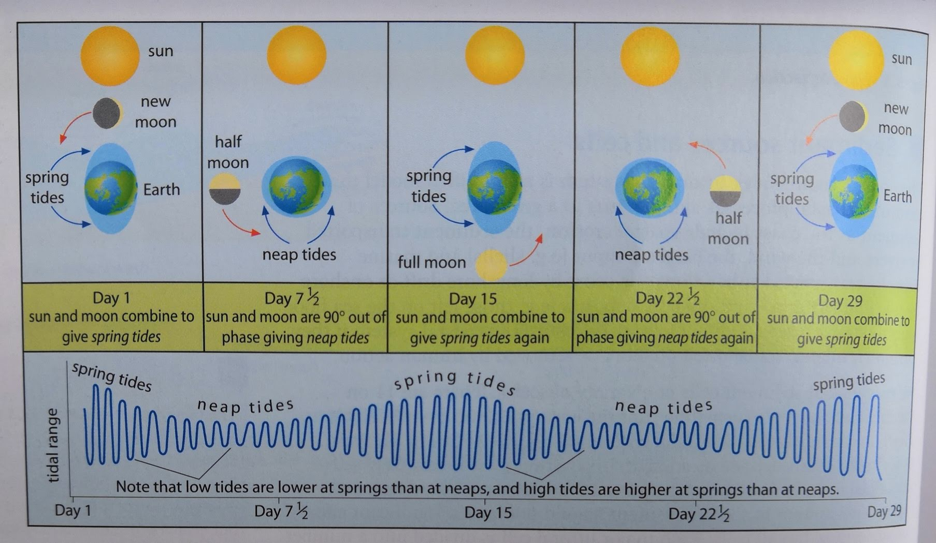
The pattern of tides is modified by the nature of the ocean bed, the proximity of land masses and the effect of the Coriolis force (which deflects water to the right in the northern hemisphere). Local factors also influence the nature of tides. Places with a narrow neck of water usually experience the greatest local tidal range. For example, when water from the Atlantic Ocean and North Sea becomes confined in the narrowest sections of the English Channel, the tide can be 6m higher than in the open seas. The Severn Estuary has a particularly large tidal range of up to 13m, which at key times can send a tidal wall of water rushing upriver, known as the Severn bore. This 1m high wave can move upstream at 30km per hour, eroding the banks of the river. Conversely, in almost landlocked seas, such as the Mediterranean, the tidal range can be as little as a few centimetres.
The tidal range is important as it determines the vertical range of erosion and deposition that can be carried out by waves, the length of time that waves have to act on coastal landforms, as well as the size of area and length of time that weathering and biological activity can operate in the intertidal zone e.g. on wave-cut platforms. Tidal motion can also cause rip currents which are important for transporting sediment.
High tides can combine with storm surges that accompany intense low-pressure weather systems, resulting in enhanced rates of erosion. In 1953, a storm surge of more than 2m, combined with a high spring tide, inundated large parts of the east coast of England. December 2013 saw another storm surge with catastrophic effects for some coastal communities along the east coast (1,400 homes flooded and extensive cliff erosion).
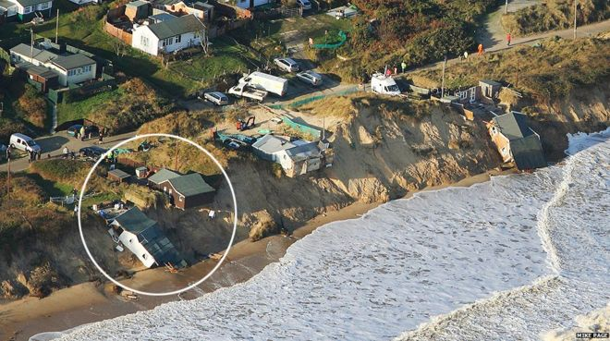
Aerial view of the cliff at Hemsby, Norfolk, after the December 2013 tidal flood resulted in homes falling down
Tasks:
- Define and explain the terms a) spring tides b) neap tides c) tidal range d) tidal bore
- Explain why tides are more important in some coastal areas than others
- To what extent do you agree that tides are just as important as marine and sub-aerial processes in determining the characteristics of coastlines (e.g. the variety of coastal landforms)?
Did You Know? The amphidromic point (tidal node) is a place where there is no tidal range.
