International Aid
International aid is the assistance that governments, non-governmental organisations (NGOs), businesses and individuals of one country give to the government and people of another country to help reduce poverty and achieve development that is sustainable.
Aid is a way for HICs to support the development needs of MICs and LICs, creating a more equal world by tackling moderate and extreme poverty, and redressing some of the problems caused by actions and situations from the past and present e.g. colonialism, globalisation, unfair trade and the debt burden. Aid also helps MICs and LICs to increase their presence in international trade, exporting more goods and being able to afford more imports, creating new trade opportunities for HICs. Furthermore, aid can help to reduce political instability in MICs and LICs, with improved security enabling HICs to gain access to raw materials and markets.
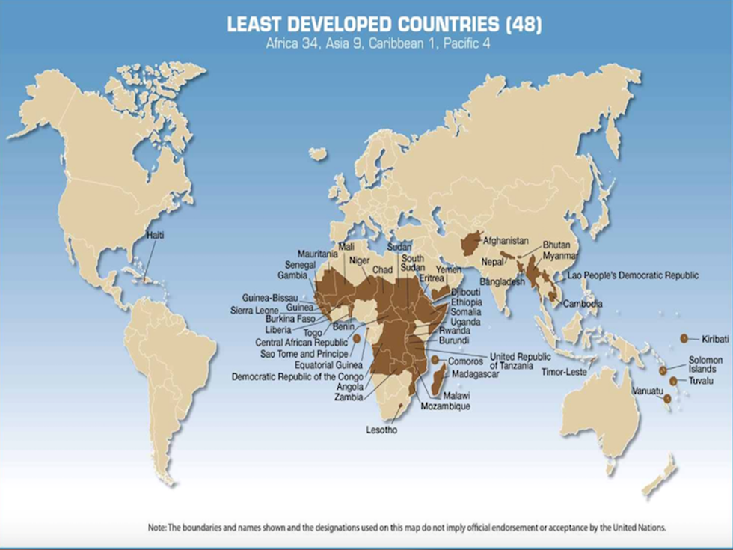
The world’s 48 Least Developed Countries. Africa is home to 34 of them (Source: United Nations)
The need for aid in numbers:
- At least 700 million people are still living in extreme poverty (<$1.90 per day)
- More than 1.5 billion people are living in moderate poverty ($1.90 to $3.10 per day)
- More than 100 million children do not receive even a basic education
- More than 500 million women are illiterate
- More than 800 million people go to bed hungry every day
- More than 1 billion people use unsafe sources of drinking water
- More than 2.5 billion people do not have basic sanitation
- Around 5 million people, mostly children, die each year from water-borne diseases
- Around 6 million children die each year from malnutrition before reaching their 5th birthday
- Between 200 and 300 million people are infected with malaria each year, leading to loss of productivity and nearly half a million deaths
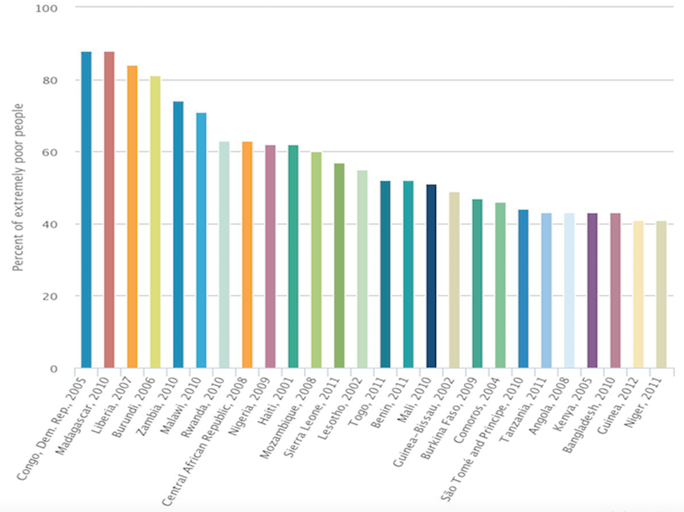
Countries with the largest percentage of extremely poor people. 24 of the 26 countries are in sub-Saharan Africa; Haiti and Bangladesh being the two exceptions (Source: World Bank)
- In sub-Saharan Africa, 47% of the population continue to live in extreme poverty, a total of 400 million people
- In DR Congo, Madagascar, Liberia and Burundi, more than 80% of the population live in extreme poverty.
What is international aid? What types of aid exist?
International aid is sometimes referred to as overseas or official development assistance (ODA). There are many types of aid, and aid donors, each one having a different role in supporting the needs of MICs and LICs, and therefore offering a different combination of advantages and disadvantages. A variety of aid types and donors is therefore likely to be the best approach to help an MIC or LIC to achieve sustainable development for all its people, living in both rural and urban settings. One type of aid or one aid donor cannot fix all the problems within a country!
Relief aid is also known as humanitarian aid or emergency aid. It involves the supply of food, water, shelter, medicines and medical assistance to people in distress or immediate threat of death, often the result of war or natural disasters. International organisations providing relief aid include the World Food Programme (WFP) which is a branch of the United Nations (UN), the United Nations High Commissioner for Refugees (UNHCR) which is the UN Refugee Agency, and the International Committee of the Red Cross (ICRC) which is an independent, neutral organisation. In addition, the governments of HICs, such as the G7 nations, and many other non-governmental organisations (NGOs) support international efforts to provide relief aid.
Development aid involves assistance to support economic or social development that will reduce poverty and improve quality of life in the long term rather than simply to alleviate an immediate crisis. It is usually measured in value using official development assistance (ODA) data. Aid includes grants, low-interest loans and debt relief. Grants and loans are often for specific projects e.g. new schools, hospitals, roads and HEP stations. Development aid also includes technical assistance, such as skilled advisers, engineers, doctors and teachers. The Organisation for Economic Co-operation and Development (OECD), whose membership comprises 35 HICs and MICs, promotes policies that will improve the economic and social well-being of people around the world. Some of its members have met the UN target of spending at least 0.7% of their gross national income/product (GNI/GNP) on development aid. The UK has met this UN target annually since 2013, as have Denmark, the Netherlands, Norway, Luxembourg and Sweden.
Tied aid is aid given on the condition that the receiving country spends money on goods or services in the donor country. Such aid implies that the reasons for giving aid are not entirely altruistic. Economic and geopolitical reasons are usually the motivation for tied aid. Following criticisms of the UK’s aid in past decades being distributed as tied aid, the UK government changed its rules to make it illegal for tied aid to be given. However, many other donor countries continue to impose tied aid on receiving countries.
Bilateral aid is assistance given by one country’s government (typically an HIC or MIC) directly to another country’s government (typically an LIC). This is usually the largest share of a country’s aid budget. As with tied aid, economic and geopolitical considerations influence decisions on which governments receive the aid, as well as humanitarian considerations.
Multilateral aid is assistance (typically money) provided by governments of HICs and MICs to international organisations, such as the UN, World Bank and the International Monetary Fund (IMF). These international organisations then allocate funds to alleviate poverty and promote development in LICs.
What should be the aims and objectives of international aid?
In September 2000, 189 heads of state gathered at the UN’s Millennium Summit in New York. World leaders committed their countries to reducing extreme poverty through a series of targets that became known as the Millennium Development Goals (MDGs). These included the target of halving the proportion of people living in extreme poverty by 2015.
The UN Millennium Declaration
Goal 1. Eradicate extreme poverty and hunger
Goal 2. Achieve universal primary education
Goal 3. Promote gender equality and empower women
Goal 4. Reduce child mortality
Goal 5. Improve maternal health
Goal 6. Combat HIV/AIDS, malaria and other diseases
Goal 7. Ensure environmental sustainability
Goal 8. Develop a global partnership for development
The eight MDGs incorporated 21 targets to be achieved by the end of 2015. The UN, with its many associated agencies, such as the World Health Organisation (WHO), Food and Agriculture Organisation (FAO) and the United Nations International Children's Emergency Fund (UNICEF), had a crucial role to play in global poverty reduction.
In addition, 23 global organisations, including the World Bank, IMF and the World Trade Organisation (WTO), declared themselves committed to achieving the MDGs. This marked the largest ever international attempt to rid the world of extreme poverty.
Numerous NGOs, non-profit organisations, campaign groups and private foundations also committed themselves to supporting the MDGs. Examples include World Vision, Oxfam, Save the Children, Millennium Promise, Make Poverty History, and the Bill & Melinda Gates Foundation.
Therefore, the aid spending by each of the above groups should be judged on the extent to which it has supported one or more of the MDGs, as progress towards achieving the MDGs is the benchmark for success.
2016 saw world leaders adopt the new 2030 Agenda for Sustainable Development. At the heart of this agenda is an even more ambitious set of goals, officially known as the Sustainable Development Goals (SDGs) or Global Goals. These are a set of 17 goals and 169 targets to combat poverty, hunger, inequality, climate change and environmental degradation by 2030 – with the key target of ending extreme poverty everywhere.
Task 1: Define each of the following types of aid - Relief Aid; Development Aid; Tied Aid; Bilateral Aid; Multilateral Aid.
Task 2: Give a named example for each of the above types of aid and comment on how useful the aid was in each case.
Task 3: Define each of the following terms: Extreme Poverty; Moderate Poverty; Sustainable Development; Gross National Income; Geopolitical
Task 4: Define the term ‘non-governmental organisation’ (NGO). Describe and explain the role of NGOs in providing aid.
Task 5: Critically evaluate the impacts of aid on receiving countries since the Year 2000.

