The International Debt Crisis & Debt Relief

What is the international debt crisis? When and why did it originate?

During the 1970s and early 1980s, large commercial banks from the US, Europe and Japan, along with their governments and international agencies, such as the International Monetary Fund (IMF) and World Bank, made substantial international loans to the governments of Brazil, Mexico and other LICs, including sub-Saharan African countries. The 1970s saw an explosion in international debt, and by 1982 LICs owed over $500 billion to these Western-dominated institutions.

A significant reason for the growth in international lending was the quadrupling of oil prices in the early 1970s which created unprecedented wealth for the world’s oil-rich states, particularly Saudi Arabia, Iran, Iraq and Kuwait (members of the OPEC cartel). Their ‘petrodollars’ were deposited in European and US banks who invested these funds in the form of loans to LICs. The banks saw lending to governments in LICs as less risky and more profitable than lending to businesses in their own countries. Unlike businesses, governments cannot declare bankruptcy! The high yield on the loans was another attraction, with many based on floating rather than fixed interest rates, lessening the risk of future inflation wiping out the value of the banks’ loan assets.

Another factor was the eagerness of LIC governments to borrow money, largely the result of their officials and professional citizens having been educated in Western universities and exposed to Western ‘development economists’ who promoted the benefits of large-scale investments by the state (government) to accelerate economic progress.

Initially, interest rates were low, with the US dollar depreciating in value at a greater rate than the rate of interest at which the LICs could borrow. This encouraged the LICs to continue to borrow, expecting to repay their debts with less valuable dollars. However, by 1980, the dollar’s depreciation had slowed and interest rates were twice the level of a few years earlier. A worldwide recession occurred in the early 1980s, and interest rates rose sharply. The recession also caused commodity markets and prices to collapse, hitting the export value of the primary products that most LICs depended on. Suddenly, LIC governments were faced with economic stagnation and massively increased interest burdens.

To make matters worse, the loans were often wasted on grandiose projects, such as HEP schemes, airports and jungle roads, that represented political priorities but were not a priority for the majority of citizens.

Furthermore, the banks had been prepared to lend money to countries with poor governance, corrupt leaders and limited democracy. Corruption often diverted funds into the pockets of politicians and business people. For example, Mobutu Sésé Seko, leader of DR Congo from 1965 to 1997, siphoned off much of the country’s international loans, enabling him to amass a personal fortune of at least $4 billion while in office, to the detriment of the country’s economic and social development.

By 1982, many LICs could not pay their debts, forcing commercial banks, Western governments and the IMF to reschedule the loans – a form of debt relief. This involved stretching out the payment periods and decreasing the interest rates. Mexico was one such country to default on its loan repayments and seek IMF assistance. New short-term loans were advanced by the IMF on the condition that LICs followed prescribed austerity measures. However, these measures were only a ‘band-aid solution’ that prevented the banks from becoming insolvent, and they did little to help the LICs overcome their long-term debt problems. Many were spending 50% of their income from exports on servicing their debts by paying interest to Western-based banks. This was clearly unsustainable, and in 1987, Brazil, the largest international debtor, announced that it too could no longer pay interest on its debt.

To sum up, the irresponsible lending on the part of creditors, mismanagement on the part of debtors, and the worldwide recession all contributed to the debt crisis of the early 1980s.

International debt crises are not just the preserve of LICs and MICs in Africa, Latin America and Asia. Equally, debt crises have occurred at different times since WW2. For example, there has been a recent international debt crisis affecting MICs, a result of the Global Financial Crisis of 2007-2008 that triggered a global economic recession in the years that followed. This can be seen by what is often referred to as the sovereign debt crisis that crippled the governments of Greece, Spain, Ireland, Portugal and Cyprus, all of whom required assistance from the IMF and European Central Bank (ECB).

What is the impact of international debt?

LICs pay a high price to service their debt, and this cost is particularly born by people living in poverty. The massive debt payments that poor countries owe to Western-based banks and to multilateral creditors like the IMF and World Bank take resources away from investments that benefit ordinary people and contribute to social and economic development. According to Oxfam International's April 1997 report, Poor Country Debt Relief, “Debt repayments have meant health centres without drugs and trained staff, schools without basic teaching equipment, and the collapse of agricultural extension services." The obligation to meet debt service payments also means that aid from other countries like the US is often used to refinance debt payments rather than improving healthcare, education and other vital social services.

The IMF and World Bank require economic restructuring via Structural Adjustment Programmes (SAPs) before a country can qualify for debt relief. These requirements inevitably override national government priorities, and can include reducing inflation, removing price controls, reducing tariffs and other restrictions on international trade, and government downsizing. While in the long run they may help a country become more competitive in the global market, in the short run they can lead to local business failures in the face of global competition, massive lay-offs, a ‘race to the bottom’ in terms of wages and resource prices, and even less investment by government in public and social services, exacerbating the suffering of the most disadvantaged.

What is debt relief? When did it become widespread? Who provides it? Which countries have benefitted?

Debt relief involves measures that cancel or reduce external debt repayments to sustainable levels. Usually, a part of a debt is written off or the amount owed is reduced through more favourable repayment terms. Debt relief is therefore a form of aid.

Some debt relief measures for LICs were introduced by commercial banks, Western governments, the IMF and World Bank in the 1980s, but more substantial debt relief measures were not introduced until 1996 when the IMF and World Bank jointly launched the Heavily Indebted Poor Countries (HIPC) Initiative. This debt relief initiative aims to ensure that no poor country faces a debt burden it cannot manage.

HIPC Initiative - eligible or potentially eligible countries in 1999. Source: World Bank…

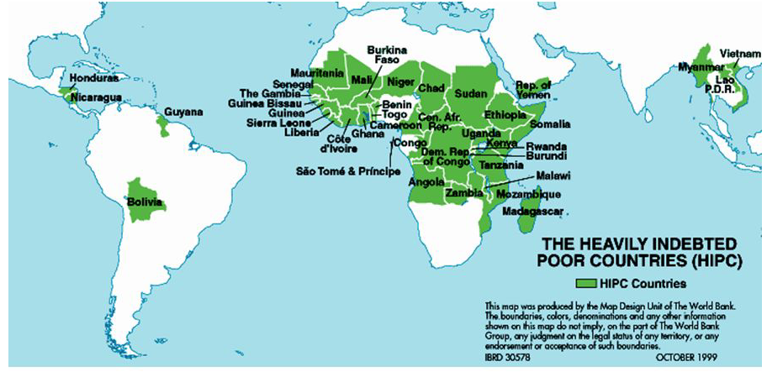

To accelerate progress with the Millennium Development Goals (MDGs) announced in September 2000 by UN Secretary-General, Kofi Annan, finance ministers from the G8 nations agreed, in 2005, to cancel an extra $40-55 billion of debt owed by members of the HIPC Initiative. This new commitment, known as the Multilateral Debt Relief Initiative (MDRI), built on the HIPC Initiative introduced in 1996, which aimed to provide debt relief and low-interest loans to cancel or reduce external debt repayments to sustainable levels. Most of this debt was owed to the IMF, World Bank and the African Development Bank (AfDB), institutions that receive significant funding from the governments of the G8 nations. In 2007, the Inter-American Development Bank (IaDB) also decided to provide additional (‘beyond HIPC’) debt relief to the South and Central American HIPCs.

However, the HIPC countries are required to complete a two-step process, each with multiple conditions, before full debt relief can be received. Conditions include a track record of good financial management, a lack of corruption, a commitment to divert more resources into improving health and education, as well as other poverty reduction strategies.

Debt reduction packages under the HIPC Initiative have benefitted 36 HIPC countries, 30 of them in Africa, by providing $76 billion in debt-service relief over time. Nevertheless, despite paying out more than $25 billion in loan repayments annually, African countries still owe more than $300 billion, and many have little chance of being able to repay their debts. In 2014, Eritrea, Somalia and Sudan were identified as potentially eligible for HIPC Initiative assistance, but had not yet reached the first step decision point to receive interim debt relief.

HIPC Initiative – 39 eligible or potentially eligible countries in 2017. Source: IMF…

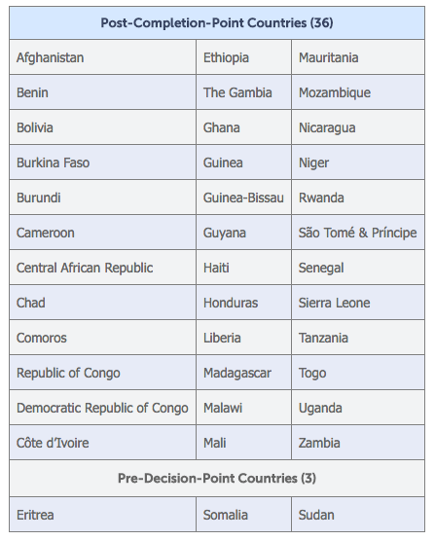

Successes of the HIPC Initiative:
- Debt servicing payments have declined
- Increased expenditure on healthcare, education and other vital social services
- Ability to focus on exports, increasing foreign exchange earnings
- Stronger management of borrowing and debt levels

Weaknesses of the HIPC Initiative:
- SAPs have led to cuts in some areas of government expenditure, and the sale of state assets to overseas transnational corporations (TNCs)
- More cash crops are being exported, reducing the quantity available for domestic consumption
- Full debt relief is only available from the largest creditors (IMF, World Bank, AfDB, IaDB), so countries may still have stockpiled debt from smaller creditors that must be paid

Tasks:
- Explain the international debt crisis of the 1980s.
- How is international debt similar to, and different from, personal debt?
- To what extent has the international debt crisis since 2008 been different to the one in the 1980s?
- ‘An international debt crisis has winners and losers’. How far do you agree with this statement?
- Evaluate the solutions to the international debt crisis of the 1980s.

