Ageing Population Case Study – Japan – Managing Population Change
Link to Specification:
- Issues of ageing populations - the implications of an ageing population structure for the balance between population and resources
- Social, economic and political impacts/consequences of ageing populations
- Strategies for coping with the challenges of ageing populations

Ageing Population – a population with a high % of elderly i.e. 65+, usually linked to an HIC but may also occur in LIC Rural areas due to Rural-Urban Migration.

Optimum Population – this does not just depend on the total population of a country or region. It is much more dependent on the age and sex structure of the population. HICs are particularly concerned about the demographic time-bomb problem caused by their rapidly ageing populations. A falling workforce that has to support an increasing elderly population doesn’t encourage an optimal population situation.

Sustainable Development - an ageing population is not a sustainable population structure as it puts a huge strain on the resources of a country e.g. medical infrastructure, health and social care budgets. It also leads to a higher dependency ratio as the economically active must pay more tax to provide these resources. Government responses in HICs, such as raising retirement age, childcare vouchers, and increases in national insurance, reflect their concern that an ageing population puts a huge strain on resources and is therefore not sustainable.

Population | Examples | Evidence/impacts | Responses
Ageing Population | Japan, Italy, Russia,  UK | - BR low & decreasing  - LE increasing  - Increased % 65+  - Decreased % economically active  - School & university closures  - Growing strength of grey pound  - Development of elderly related services  Lots more of course! | - Increase the retirement age beyond 65 (rising to 70 in UK before 2050)  - Rate of tax/NI increasing  - Compulsory private pensions for all workers  - Immigration schemes (skilled migrant scheme in Australia)  - BR related policies e.g. childcare vouchers  Lots more of course!

Info on Japan

Population 2012 = 127.5 million  Population has fallen by 284 000  Number of people over 65 = 30 million  Over 65s account for 24% of the populations  Children aged 15 and under = 13% | Life Expectancy at birth is highest in the world.  LE for men is 80; LE for women is 86.  Birth Rate = 8.23 Death rate = 9.27  Fertility rate is in the range 1.41 to 1.37, so below replacement level.  The population is ageing and declining in size at the same time

More Facts & General Information on Japan
- At the current birth rate, Japan’s population will shrink by a third in the next 45 years - from 128 million today to 87 Million by 2060
- In 2013, the death rate exceeded the birth rate for the seventh year in a row (1 million births / 1.3 million deaths)
- The proportion aged 65 or older exceeds 20%, and is expected to double to 40% by 2060
- There are more than 50,000 people aged 100+
- The national workforce by 2060 will only be half of the total population
- The average life expectancy is expected to increase by 4+ years to 84 for men and 91 for women by 2060
- A generation of young geeks prefers immersing themselves in virtual reality games & relationships rather than real relationships
- A government survey in 2010 found that 36% of Japanese males aged 16-19 had no interest in sex
- Some blame the economic stagnation of the economy during the past 20 years. The young generation doesn’t feel they will match the wealth of the older generations, and so don’t want to commit to relationships
- Marriage rates are plummeting, and very few babies are born outside marriage – just 2%
- 61% of unmarried men aged 18-34 have no girlfriend. Without relationships, government incentives to have more babies are bound to fail!
- Japan’s demographic time-bomb is also linked to the lack of immigration. Only 1 in 60 were born abroad, compared to 1 in 8 in the UK
- The winners will be pharmaceutical companies, companies running care homes or selling anti-ageing products for the elderly, as well as companies involved in leisure/tourism activities that are attractive to an elderly population. Adult nappies outsell baby nappies.
- The losers will be consumer electronics companies, breweries, schools, universities and the government who has to provide social security payments, such as pensions, to the elderly, and will suffer from a smaller total economy and rising debt levels
- In the town of Yubari, in the north of Japan, only 1 primary school survives, when once there were 21 schools. The town’s population has plunged by 90% since the 1960s. The young have fled, and nearly 50% of the remaining 10,000 residents are aged 65 or older
- Whilst over 50% of Japan’s elderly are living in the cities, the rest live in remote rural areas where there are not enough facilities and services to cope. In Tokyo alone there are about 400 residential homes for the aged but it is estimated that this is already too few- 800 are needed now and that need is going to grow. Within the elderly cohort there are 2.5 million with some form of dementia, adding to the problems of care and the money to finance it.
- Nearly 20% of Japan’s prison population is aged over 65. In the UK it is less than 4%
- Japan operates a universal care system where you receive care according to your physical or mental need and not dependent on income level or family situation. This is severely under pressure as the economy shrinks. The percentage of the elderly living with a child has fallen from 87% to 48% as families become dispersed due to moving for jobs and as attitudes change. However, Japan has been working on the problems of ageing for over 20 years…
- The Japanese government has been adopting pro-natalist policies to stimulate the birth rate, although not very successfully. Less than 2% of Japan’s population are foreigners, but immigration has been rejected as a suitable solution because of fear over its negative effects on social services and social cohesion. Japanese companies have been more successful in investing in robot technology to boost industrial productivity, without the need for extra workers
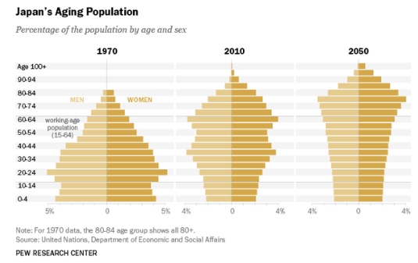
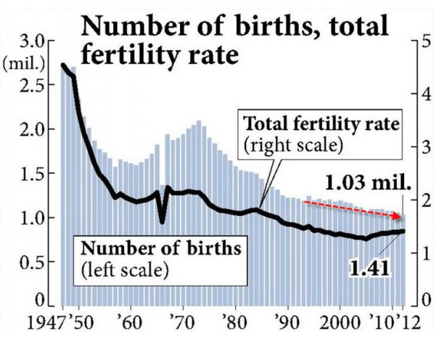

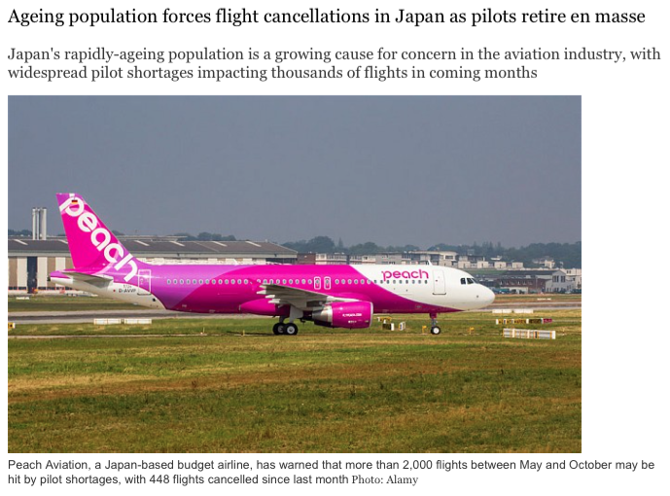
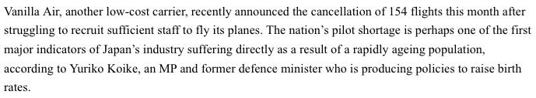
Actions to tackle the ageing problem in Japan include:
- Keep the over 65s active so that being in better health means that the years of aged dependency are reduced. Provide sports facilities etc.
- Encourage over 65s to take on jobs in the community (after retiring from their main job) such as gardening, helping out in kindergarten etc. They receive a small payment and pay some tax which helps the economy.
- Total retirement being pushed up into mid 70s
- Encouraging more women into the workforce when younger. Japan has a low participation rate for a developed country. Helps economy.
- Using public money to allow women to freeze their eggs when young, and use them to help with conception later in life.
- Research into use of robotics to help with low-level tasks in elderly homes and hospitals. Robots to dispense medicines or to remind elderly person living on their own to take medicine or even to eat!

Tasks: (use all the available information above and further research to answer the following)
1. Describe the changes to Japan’s total population, birth & fertility rates and its population structure in recent decades.
2. What is the evidence that Japan is a Stage 5 country on the DTM?
3. Outline the factors (causes) that have been responsible for Japan’s population change in recent decades.
4. What are the social, economic and political implications (impacts ++) of Japan’s population change?
5. How has population change affected the character of Japan’s rural and urban areas?
6. Create a table to summarise the winners and losers from Japan’s population change.
7. How is the government addressing (managing) the problems created by Japan’s population change?
8. Why might these solutions not go far enough to achieve sustainable development? Suggest what further solutions might be necessary to achieve a better balance between population and resources (and therefore more sustainable development).
Extension:
Identify a European country with an ageing population problem that resembles Japan. What are the similarities in causes and/or solutions? What are some of the differences in causes and/or solutions? Overall, to what extent is the European country managing its population change to achieve sustainable development more effectively than Japan?

