The Causes, Nature and Problems of Debt for Countries

What is national debt? What is the nature of national debt?

National debt is the debt owed by the governments of countries, sometimes referred to as public debt, federal debt or simply government debt. It is essentially the accumulation of the annual budget deficits of governments, known as national deficits, which occurs when their annual spending (e.g. on public services such as health, welfare, education and defence) exceeds the income they generate through the collection of taxes and other means.

National debt is often expressed as a % of GDP. For example, the USA had a national debt of $19.8 trillion in late-2016, amounting to 106% of the country’s GDP. The UK’s national debt in early-2017 stood at £1.7 trillion, around 87% of the country’s GDP. China’s national debt of $4.3 trillion, in early-2016, was considerably lower as a % of GDP than the US and UK - just 41% of China’s GDP. Even lower was Saudi Arabia’s national debt – a tiny 12% of its GDP in 2016.

US National Debt: Share of GDP…

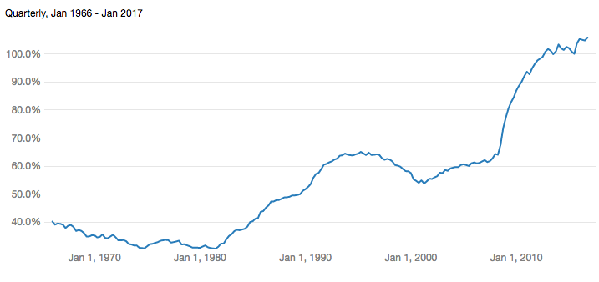

UK National Debt: Share of GDP…

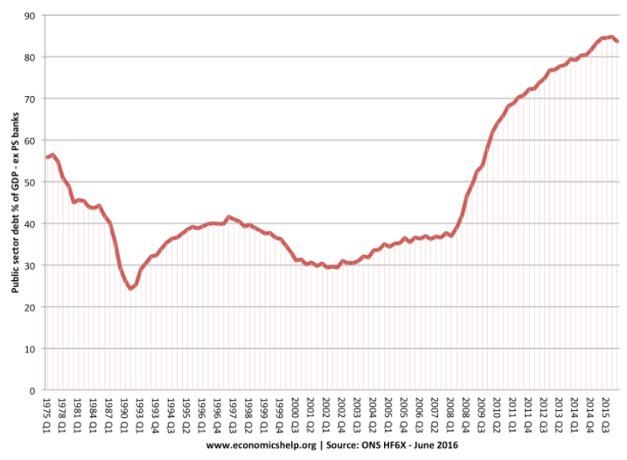

Task 1: Suggest reasons for the national debt levels of the US, UK, China and Saudi Arabia being so different.

Task 2: Compare and comment on the changing national debt levels of the US and UK shown by the graphs.

Task 3: Carry out research to identify two countries with a higher national debt as a % of their GDP than the US, and one country with a lower national debt than Saudi Arabia. Suggest reasons for their debt levels.

However, comparing a country's national debt in relation to its GDP is not necessarily the best approach, for several reasons. Firstly, GDP is very difficult to accurately measure due to its complexity, and corrupt accounting adds to the problem. In recent years, there has been increasing scepticism about the reliability of China’s economic data, with some analysts claiming the size of its economy has been overstated by as much as $1 trillion, the result of corrupt provincial officials providing bogus economic data.

Secondly, HICs, such as the US and UK, have large assets against which they can borrow money. They enjoy a strong credit rating which enables them to borrow money easily and at low cost. The result is that the interest payments on loans taken out by the governments of HICs are generally much lower than LICs and MICs, making their debt more manageable. The US government issues treasury bills, treasury notes and treasury bonds to finance its deficit by borrowing from domestic and foreign investors, as well as corporations and other governments. This allows the US government to continue to provide a full range of public services. In a similar way, the UK government sells bonds, known as gilts, to investors at home and abroad. These have to be repaid in full with interest, but the amount returned (yield) has fallen over time, making borrowing more affordable.

UK Bond Yields v National Debt…

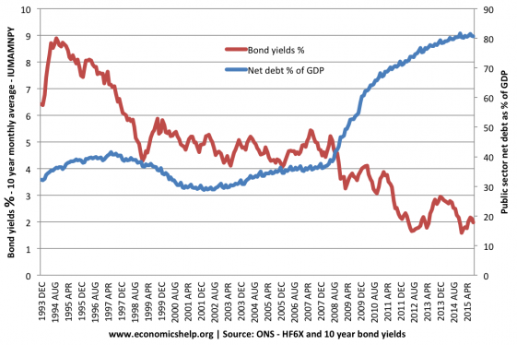

In contrast, LIC governments are faced with higher interest payments on their loans, limiting the money available to spend on public services and key infrastructure. An alternative approach to interpret national debt is therefore to compare the interest expense paid to service the debt by governments with their expenditures on specific public services, such as health, welfare education and defence. Many LICs spend more on debt service than on health and education combined.

Thirdly, in many LICs and some MICs, the informal economy (underground economy) is an important source of goods, services and income, but its contribution to the overall economy is not captured by official data collection. The true value of the GDP of these countries is therefore likely to be much higher than the reported figure.

Fourthly, a country’s national debt is not actually paid back with GDP, but with tax revenues (although there is clearly a correlation between the two). If GDP is going to be used in relation to national debt, it might be better to focus on the amount of debt on a per capita basis, since this helps people to get a better sense of the level of debt in their country. For example, the US national debt equates to around $60,000 per person, while the UK national debt equates to around £26,000 per person.

Task 4: Evaluate the usefulness of comparing HICs and LICs in terms of their national debt as a percentage of their GDP.

What causes national debt?

There are many factors that lead to governments accumulating debt. Economic recession, inflation and the cost of war are often key reasons for high levels of national debt. Political priorities clearly play a key role, and some governments will choose to increase the level of debt by investing more in public services and infrastructure as the extra spending boosts aggregate demand, can reduce inequality and helps to promotes social and economic progress in the long term. Unsurprisingly, economists disagree on whether rising national debt is really a problem! (more details on the problems in the final section).

USA: Reasons for the increase in the country’s national debt…

Rising cost of social security payments - payments are collected from present-day workers and used to support the increasing number of retirees. Longer life spans mean that payments have skyrocketed, while declining fertility rates have reduced the pool of contributing workers.

Tax cuts introduced during the presidency of George W. Bush (2001-2009) - the legacy of Bush's policies and tax cuts continue to impact on the current government’s income, thereby creating large debts.

Increasing healthcare costs - the cost of the government’s Medicare (health insurance for over 65s) and Medicaid (health insurance for poor) programs and the healthcare reforms of President Obama (2009-2017) have exceeded the projected figures. The general price rise in medical costs has been part of the problem, exceeding inflation by a wide margin.

Weak state of the economy - the US economy has been sluggish since the turn of the century. The dot-com bubble of the late 1990s soon burst, leading to recession in the early 2000s, and then a period of low growth before the Great Recession that started in late 2007, a result of the Global Financial Crisis that was caused by the excessive risk-taking of US banks. Trying to inject life into the US economy has led to further government expenditure e.g. stimulus measures through tax-cuts, jobless benefits and financial industry bailouts.

Cost of the Iraq and Afghanistan Wars - the continued involvement in these conflict zones has cost the US at least $2 trillion since 2001 (some estimates suggest as much as $5 trillion), a huge burden on the country’s national debt.

Stagnant salaries – individual taxpayers contribute nearly half of the government’s annual tax receipts, but the salaries of most Americans have barely increased so taxes collected have not grown.

Falling corporate income taxes – taxes from businesses have been showing a declining trend since 2007. The previously profitable financial sector has failed to deliver much income tax for the government since the financial crisis as the profits of banks have collapsed. The bailout of many US banks has meant an additional big hit on government finances.

Task 5: To what extent is the US government to blame for the country’s high and increasing level of national debt?

What are the problems of national debt?

Very high national debt can slow down economies. When governments borrow lots of money there is a risk that this will crowd out other investments, since investors such as banks and insurance companies will loan their funds to the government, rather than to private sector borrowers.

Large debts may also require higher rates of taxation to pay for them, limiting the government's ability to cut taxes and stimulate the economy.

High interest payments on loans can eventually trigger a sovereign debt crisis with governments unable to service their debts. Because of the Global Financial Crisis, several European countries faced the collapse of their financial institutions, high government debt and rapidly rising bond yields. Greece, Spain, Ireland, Portugal and Cyprus were unable to repay or refinance their government debt without the assistance of third-party financial institutions, such as the International Monetary Fund (IMF) and the European Central Bank (ECB), which acted as ‘lenders of last resort’. However, such financial support comes with strict conditions attached, such as austerity measures to cut public spending and increase taxes. The outcome is often a further economic recession, social unrest, political division and growing inequality, with the poor suffering the most.

Task 6: Explain why a country may experience a sovereign debt crisis and how it can deal with such a crisis.

Task 7: National debt – good or bad? Discuss.

