Rip Currents and their Role in Sediment Transportation
A rip current, often simply called a rip, is a specific kind of water current which can occur near beaches with breaking waves. A rip is a strong, localised, and narrow current of water which moves directly away from the shore, cutting through the lines of breaking waves like a river running out to sea, and is strongest near the surface of the water.
Rip currents can be hazardous to people in the water by carrying them out beyond the zone of breaking waves. Swimmers who are caught in a rip current may panic, or exhaust themselves by trying to swim directly against the flow of water. Because of these factors, rips are the leading cause of rescues by lifeguards at beaches.
A rip current forms because wind and breaking waves push surface water towards the land, and this causes a slight rise in the water level along the shore. This excess water will tend to flow back to the open water via the route of least resistance. When there is a local area which is slightly deeper, or a break in an offshore bar (sandbar) or reef, this can allow water to flow offshore more easily, and this will initiate a rip current through that gap.
Rip currents often occur on a gradually shelving shore where breaking waves approach the shore parallel to it. The surface of a rip current may appear to be a relatively smooth area of water, without any breaking waves, and this deceptive appearance may cause some beach goers to believe it is a suitable place to enter the water. Rip currents typically flow at about 0.5 metres per second, but they can be as fast as 2.5 metres per second, which is faster than any human can swim.
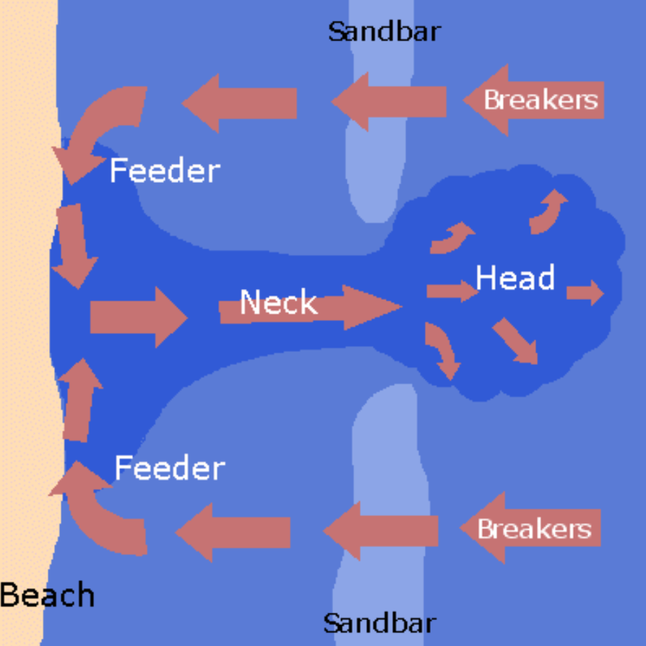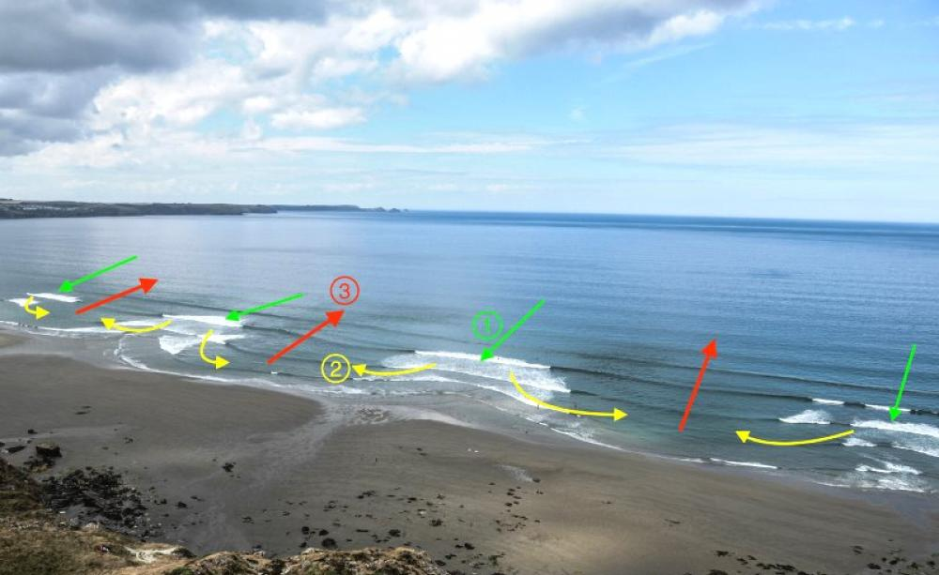
In the photo (right), waves break over the sandbars (1), feeder currents form moving parallel to the shore (2), until meeting and flowing offshore as a rip current (3)
Rip currents are more likely at low tide as offshore bars (sandbars) are frequently close to the surface of the water at this time. Waves break over these bars and cause rip currents, but as the tide rises the water depth over the sandbars increases, the wave breaking stops, and the rips become inactive.
Rip currents have long been recognised as a mechanism for offshore sediment transport, as well as an agent in beach erosion. They may also play a role in modifying beaches by creating cusps - semi-circular depressions made up of various grades of sediment (in an arc pattern) - which help to perpetuate the currents. NB – there are lots of different theories behind the formation of beach cusps!
https://www.youtube.com/watch?v=RJ4hcaJ91TY https://www.youtube.com/watch?v=PuAlDTC_gIQ
https://www.youtube.com/watch?v=M9OMIKsTuqY

