Rural-Urban Migration: How Population Change & Migration Affect the Character of Rural & Urban Areas

MEDC or LEDC example needed (we will do China, Brazil & possibly the UK or Japan)

General impacts:
Rural Area – losing area  (impacts often negative, some positive) | Urban Area – gaining area (impacts a mix of positive and negative)
- Loss of young men and family labour e.g. farm workers  - Services (e.g. schools) and shops may close due to lower population and the smaller local economy  - Breakup of the family unit  - Remittances from urban area may increase wealth of the rural community  - Migrants may return with new skills  - BR likely to fall due to loss of youth – ageing population with higher needs  - Strain on resources may be less. More farmland per person, so more food supply and profits | - New industries attracted by the growing pool of labour  - Increased demand for goods boosts the local economy, which attracts more shops and services (multiplier effects)  - Rising wealth attracts foreign retail chains  - High demand increases costs of housing  - Development of high rise flats and offices, as land expensive and in short supply  - Development of slums / squatter settlements  - Wages may fall due to surplus labour  - More industry and vehicle traffic increase air pollution (smog)  - Pressure on water supplies, sanitation, electricity  - BR may increase – more pressure on maternity wards, schools etc

Rural Areas in China - losing area  (impacts often negative, some positive) | Urban Areas in China – gaining area (impacts a mix of positive and negative)
China’s GDP per capita, at $10,276 in December 2019, disguises considerable regional variations that exist today. Around 40% of China’s population currently live in rural areas, with the remaining 60% living in urban areas. These urban areas are not evenly distributed, but are disproportionately situated in the coastal provinces.

- 650 million people live in China’s countryside and they are still relatively poor and uneducated
- About 290 million rural labourers have moved to the cities looking for work since 1979
- The rate of urbanisation in China has been around 3% a year
- Although more than 400 million people have been lifted out of extreme poverty, there were still 175 million living with < $1.25 dollars a day in 2010. By 2016, the figure was 45 million. Nearly all these people live in rural China. The government hopes to have eliminated this extreme poverty by the end of 2020

Per person income in the countryside is less than one third of the cities.  The poorest areas are the inland (mainly rural) provinces of Guizhou, Gansu and Yunnan, with GDP per person figures in 2018 below $6,500. Gansu occupied bottom spot with a figure of just $4,725.  For most young rural adults the only way to better their lives has been to migrate to the cities. Remittances sent back by these migrants to their family members in the interior do help to reduce the wealth gap.  The overall consequences of migration has been to lead to an increasingly ageing rural population, with too few entrepreneurial and creative people to kickstart the rural economies.  Rural land-grabbing close to the cities has also been a problem. The construction of new roads, factories and residential areas for migrant housing has led to the eviction of rural households, with very little compensation paid. Over 60,000 km2 of farmland have been lost in the last two decades.  Tibet and Xinjiang Autonomous Regions  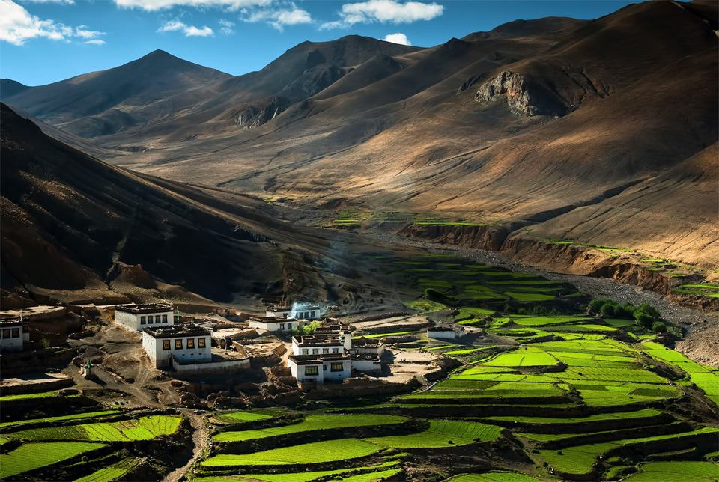  Although most rural areas in China have seen a population decrease due to out-migration, the Tibet and Xinjiang regions have witnessed population growth from in-migration. There has been a deliberate government policy to encourage ethnic Han Chinese to move to these places in order to dilute the ethnic Tibetan culture (Tibet) and ethnic Uighur culture (Xinjiang) and their local support for independence from China.  The arrival of the migrants, along with new roads, railways, an airport and industries (as part of the government’s Great Western Development Strategy) is creating fear and unhappiness among the ethnic populations of these two regions.  Since 2016, an anti-poverty campaign by President Xi has started to tackle the problem of rural poverty by relocating households from remote or challenging rural locations to government-subsidised homes in more hospitable locations, either nearby or some distance away.  In Guizhou province, around 750,000 people were moved to new villages and towns during 2017. The government hopes that similar resettlement schemes across rural China will remove 30 million people from extreme poverty by 2020, almost ending the existence of extreme poverty in China. | Coastal cities have a clear comparative advantage over inland area, and the effects of foreign investment and export-led growth has been to increase wealth levels considerably in these coastal locations.  The wealthiest areas are the coastal municipalities of Beijing, Tianjin and Shanghai, with GDP per person figures in 2018 exceeding $18,000. Beijing occupied top spot with a figure of $21,269.  The migrants themselves suffer discrimination due to the Hukou household registration system of residency permits. Rural-registered workers in cities don’t enjoy the social security, healthcare and education benefits that are offered to their urban equivalents, and they regularly suffer wage discrimination at the hands of unscrupulous employers. This limits the spoils of economic development available to the rural poor.  China’s reliance on coal-burning for 60% of its energy, along with its many industrial plants and low-grade fuel from cars, has created huge environmental problems for its urban areas. Dense smog, containing dangerous concentrations of PM 2.5 particles, regularly affects Beijing and Shanghai. A WHO report estimated that just over 1 million Chinese died prematurely in 2012 due to air pollution.  Only 10% of the estimated 20 billion tonnes of raw sewage generated in China’s cities is treated. The rest is dumped into rivers and lakes, 90% of which are heavily polluted.  Shanghai  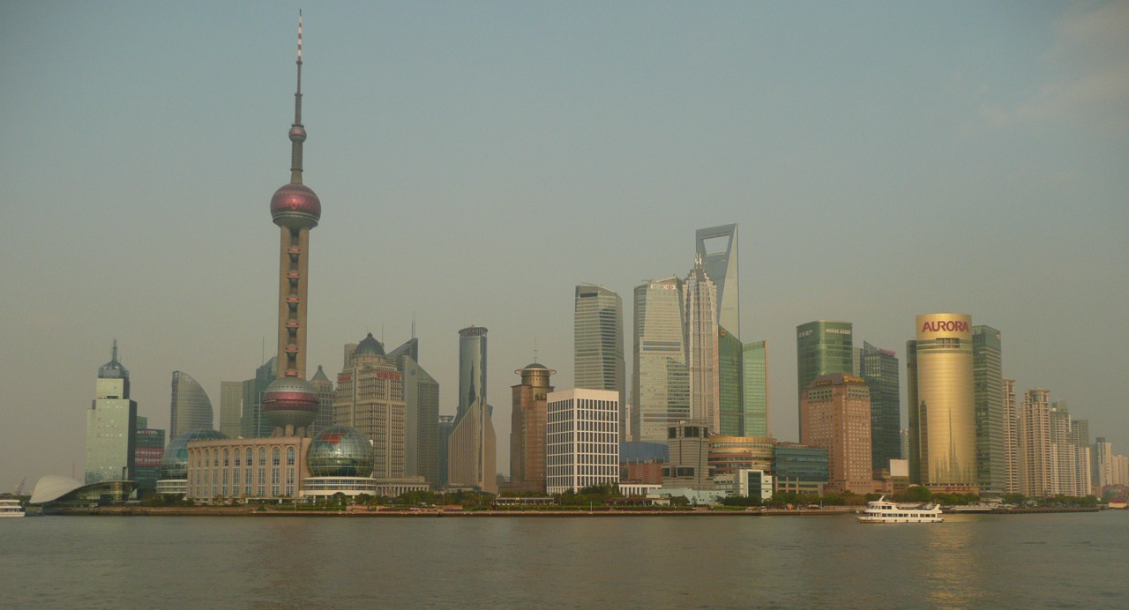  Located in the Yangtze River Delta area, Shanghai has been transformed since the 1990s to become China’s key global city. It is China’s main commercial and financial centre, as well as home to the world’s busiest container port. Its population is around 21 million.  The Pudong District, opposite the Bund waterfront area, is the new commercial heart of Shanghai, dominated by its many tower blocks.  Shanghai is now a modern, sophisticated city, with a cosmopolitan character, and can boast a highly educated and skilled workforce, as well as being home to a higher proportion of affluent consumers than anywhere else in China. Many Westerners live in the city today.  Per capita GDP for the residents of Shanghai has risen from under $1,000 in 1977 to $20,375 in 2018. The municipality’s total GDP was $470 billion in 2017. Its economy has been growing at a faster rate than China as a whole.  Around 4 million migrant labourers in the past 20 years have arrived in Shanghai, making up a quarter of the workforce. Many suffer from poorer living conditions than the locals, and with fewer rights to health or education.  Shanghai is responsible for around 10% of China’s exports of goods. It has attracted 25% of the FDI in China, much of it in the financial services sector. Manufacturing accounts for around 25% of Shanghai’s GDP, with almost 70% coming from the service sector.  One of the negative aspects from the rapid growth of Shanghai has been the considerable dislocation of its residents. More than a million households have been displaced to flats on the edge of the city, in order to make way for the massive commercial developments in the central zone.  Booming property prices have also contributed to residents being forced to live further out.

NB: Although migration is mostly rural to urban (a major factor in the increasing urbanisation of China and other countries), it is equally valid to comment on urban to rural migration (known as counter-urbanisation, and evident in the Tibet and Xinjiang region of China).

Tasks:
- Name 3 rural and 3 urban locations in China (provinces, districts or settlements)
- Explain the causes of rural-urban migration in China (refer to specific examples of push & pull factors)
- Estimate the % of rural-urban migration that is down to economic, social, political, environmental causes/factors. e.g. economic = x%, social = y%...
- Comment on the role of the Chinese government in rural-urban migration
- Discuss the impacts of rural-urban migration on China’s rural and urban areas
- Explain why there is also likely to be a smaller counter stream i.e. urban-rural migration
- Do you think the Chinese government is likely to want the rate of rural-urban migration to increase or decrease in the near future? Justify your answer

