Tidal Sedimentation in Estuaries

What is an estuary?
A partially enclosed coastal body of water with one or more rivers or streams flowing into it, and with a free connection to the open sea. Coastal plain estuaries (sometimes called drowned river valleys) are formed when rising sea levels flood existing river valleys.

Estuaries form a transition zone between river environments and maritime environments. In estuaries, the salty ocean mixes with a freshwater river, resulting in brackish water. Brackish water is somewhat salty, but not as salty as the ocean. Water continually circulates into and out of an estuary.

In areas with large tidal ranges (e.g. the Severn Estuary), an estuary tends to be triangular with shifting banks of sand, silt and clay (see below).

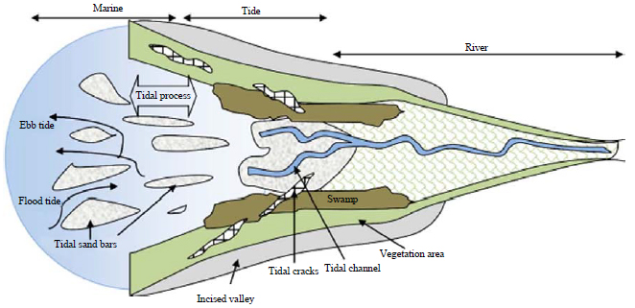

Flood Tide – incoming phase of the tide when the tide flows into the shore (flood current)
Ebb Tide – outgoing phase of the tide when the tide drains away from the shore (ebb current)

Where the tidal range is low, the effect of the water is less. Sedimentation (deposition) in estuaries is increased by their relatively sheltered nature. Large volumes of material are carried by suspension. Deposition occurs at high tide when there is little flow. Clay carried by the river flocculates when it meets the saltwater and sticks together becoming heavier and therefore being deposited.

Vegetation also causes deposition as it slows the speed of water which increases deposition. This develops inter-tidal mudflats which overtime may become higher than the height of the estuary. These may become colonised by vegetation, becoming saltmarshes. The intertidal zone (zone between high and low tide) experiences severe environmental changes in salinity, tidal inundation and sediment composition. Halophytic (salt tolerant) plants have adapted to the unstable, rapidly changing conditions. Saltmarshes may also occur behind spits or barrier islands.

What is the sequence for saltmarsh formation?
- Silt and mud deposited to form inter-tidal mudflats (covered at high tide; uncovered at low tide
- Blue-green algae and eel grass develop on the mudflats, slowing down water and trapping more mud, raising the level of the mudflats. These are the pioneer plants.
- Mudflats are uncovered for longer, allowing plants, such as glasswort, to colonise the mudflats and trap more mud
- Shorter inundation times allow other plants, such as spartina (cordgrass), to colonise the mudflats. Spartina is the dominant vegetation in UK saltmarshes as it grows all year round and has a root system that can anchor it in up to 2 metres of sediment. It further slows the tidal flow and traps even more mud.
- Eventually, a sward zone develops – an area of saltmarsh only covered by the sea for an hour a day. In the sward zone, grasses such as red fescue, and plants such as sea aster and sea lavender grow (all are halophytes)
- As the high tide retreats, creeks form, along which the receding seawater drains
- Saltmarshes can grow upwards at up to 25mm per year. Eventually, the land is built up until it is always above the level of the highest tides. Reeds and rushes become established, and eventually, shrubs and woodland (alder, ash and oak) can start to grow
- The development of a coastal saltmarsh is an example of plant succession
- UK examples of saltmarshes include the north Norfolk coast near Blakeney, the Essex coastline between Southend and Felixstowe, and the area to the west of Spurn Point in the Humber Estuary

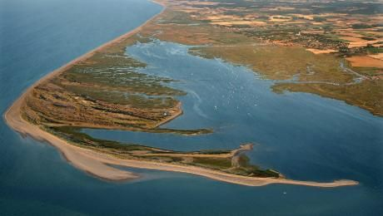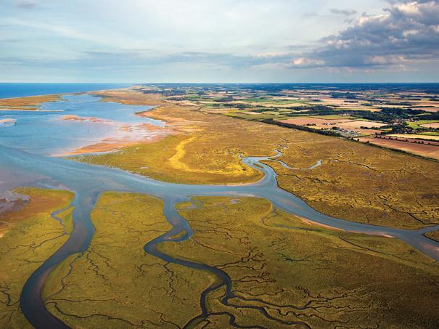
Blakeney Point: Spit & Saltmarsh

