Unfair Trade v Fairtrade
Farmers and workers at the beginning of the chain don’t always get a fair share of the benefits of trade. There are lots of other reasons why trade is often unfair (see examples further down this page). Fairtrade is an alternative approach to traditional trade and is based on a partnership between producers and consumers. Fairtrade offers farmers a fairer price and protects them against very low prices. This allows them the opportunity to improve their lives and plan for their future. Fairtrade offers consumers a powerful way to reduce poverty through their everyday shopping.
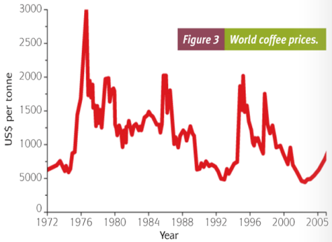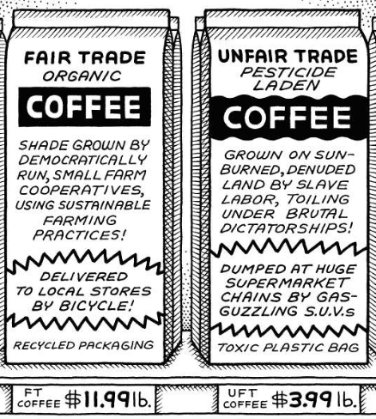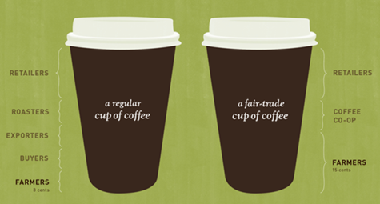
https://www.youtube.com/watch?v=cfVS1vbXyXo (1.42 min - Unfair Trade: Fair Trade Campaign)
https://www.youtube.com/watch?v=7K4G5-ydhS0 (1.14 min - Fair Trade Certified Goods)
https://www.youtube.com/watch?v=ozHGQ3_ADIM (1.26 min – Ironic Look at Unfair Trade)
Examples of Unfair Trade:
- Control over prices of agricultural products is in HICs e.g. the commodity markets of London and New York. LICs producing agriculture products have little control over price, impacting on their export income.
- Many HICs put quotas on products coming from LICs in order to protect their own farmers. Tariffs are also put on some LIC agricultural products making them more expensive than home grown produce.
- Trading blocs, like the EU, subsidise their own farmers even if the agricultural produce is more costly than farm goods coming from an LIC e.g. sugar or rice. The US subsidises its rice growers (keeping them in business) even though imported rice from Central America is cheaper. This has led to some rice farmers in Honduras going out of business as they couldn’t send their rice to the US.
- Crops can be lost due to drought, tropical cyclones, pests, flooding that affect many LICs e.g. flooding in Bangladesh, Tyhoon Haiyan in the Philippines.
- HICs demand perfect produce (especially fruit and veg) so a lot of the crop of LICs cannot be sold and is therefore wasted.
- Farmers in LICs can’t afford fertilisers and pesticides so end up with low yields and low income.
- HICs dump surplus food on the market reducing the world price or send it to LICs as food aid, reducing the chance of LIC farmers selling their own crops.

FairTrade:
Fairtrade is a movement whose goal is to help producers in LICs achieve better access to markets, including fair prices, and benefit from sustainable farming practices. It primarily focuses on merchandise trade, usually agricultural products, which are exported from LICs to HICs. The movement advocates the payment of higher prices to producers, as well as improved social and environmental standards.
The thinking behind the Fairtrade movement is grounded in the belief that markets often fail producers and/or consumers, with world trade practices promoting the unequal distribution of wealth between nations. In particular, producers in LICs do not have fair or equal access to world markets. Buying products from these producers at a fair price is a more efficient way of promoting sustainable development for them and their communities than giving them aid.
Fairtrade goods were initially sold through small specialist stores, but recent decades have seen fair trade products on sale in mainstream supermarkets. It was the arrival of the first Fairtrade labelling initiatives that helped the sales of fair trade products to take off. In 1988, the world’s first Fairtrade label was launched under the brand name, Max Havelaar, a Dutch development agency initiative. This saw the first Fairtrade coffee from Mexico being sold in Dutch supermarkets.
Today, the international Fairtrade system, made up of Fairtrade International and its member organisations, represents the world's largest and most recognised fair trade system. There are thousands of products that carry the FAIRTRADE Mark. Fairtrade Standards exist for food products ranging from tea, coffee and wine to bananas, mangoes, cocoa and nuts. There are also standards for non-food products such as flowers and plants, footballs and seed cotton.
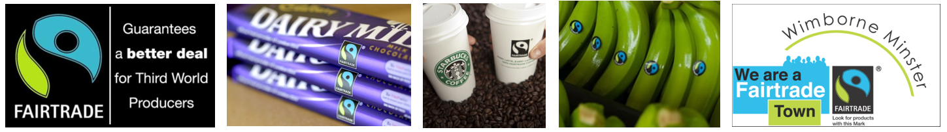
Fairtrade Standards: One set of standards applies to smallholders that are working together in cooperatives or other organisations with a democratic structure. The other set applies to companies who employ large numbers of workers on plantation estates, with the employers paying decent wages, guaranteeing the right to join trade unions, ensuring health and safety standards and providing adequate housing and/or other facilities.
Fairtrade Minimum Price: this price aims to ensure that producers can cover their average costs of sustainable production. It acts as a safety net for farmers at times when world markets fall below a sustainable level. When the market price is higher than the Fairtrade Minimum Price, the buyer must pay the higher price. Producers and traders can also negotiate higher prices on the basis of quality.
Fairtrade Premium: This additional money goes into a communal fund for workers and farmers to use to improve their social, economic and environmental conditions. The use of this additional income is decided upon democratically by producers within the farmers’ organisation, or by a workers' committee on a plantation. The Premium is invested in education and healthcare, farm improvements to increase yield and quality, or processing facilities to increase income.
Benefits of Fairtrade…
- Stable prices for producers due to the Fairtrade Minimum Price, even when world market prices fall.
- Additional funds for producers due to the Fairtrade Premium which helps producers to improve the quality of their lives e.g. education, healthcare and farm improvements
- Producers are involved in decisions that affect their future e.g. prices, premiums, standards and strategy, by jointly owning and managing Fairtrade International.
- Consumers can buy products in line with their values and principles, supporting producers who are struggling to improve their lives.
- Environmentally sustainable farm practices, including progress towards organic farming, as well as erosion and waste management.
Problems with, and Criticisms of, Fairtrade…
- Nearly all the extra price paid by consumers remains in the countries where the products are purchased.
- Certification brings extra costs to farmers, while some certification standards are not always enforced.
- The Fairtrade Minimum Price can encourage overproduction and therefore lower prices for non-member farmers.
- Political values of the Fairtrade movement are being imposed on producers (from small farmer cooperatives to huge TNCs), retailers and consumers.

General Tasks:
- Explain how Unfair Trade e.g. subsidies, quotas and tariffs work against LICs.
- Outline the aims and principles of Fairtrade.
- What types of products are sold using Fairtrade principles?
- What is the difference between Free Trade and Fairtrade?
- Outline the role of the Fairtrade Standards (incl. Fairtrade Minimum Price and Fairtrade Premium).
- Explain the benefits to the following from Fairtrade:
  - Producers
  - Consumers
  - Communities
  - Environments
- Explain why Fairtrade has its critics.
- Read the article ‘Is Cadbury's move the end for Fairtrade’ at bbc.co.uk/news/business. Discuss the positives and negatives arising from Cadbury’s move.
- With reference to one or more examples, assess the impacts of Fairtrade.
- If Free Trade existed in full, would Fairtrade still be needed? Discuss.

Fairtrade Case Study – Bananas in the Caribbean: Windward Islands e.g., St Lucia, Dominica, St Vincent, Grenada
https://www.youtube.com/watch?v=wpGMeQXyr5w (9.08 min - Nick Hewer backs Fairtrade for Banana Farmers in St Lucia)
Case Study Tasks:
- Describe how Fairtrade is helping banana growers in the Windward Islands i.e. what are they doing? what are the benefits of Fairtrade to the growers and the wider community?
- What aspects show that this Fairtrade scheme is an example of sustainable development?
- Is the banana shown below a Fairtrade banana or not? Justify your answer.
