The World Trade Organization (WTO)
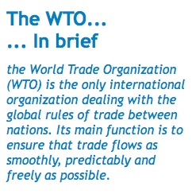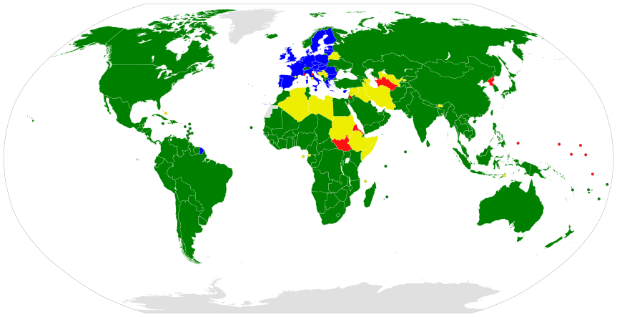
Consumers and producers know that they can enjoy secure supplies and greater choice of the finished products, components, raw materials and services that they use. Producers and exporters know that foreign markets will remain open to them. The result is also a more prosperous, peaceful and accountable economic world.

The World Trade Organization came into being in 1995, following the Uruguay Round of trade negotiations (1986-1994). Its HQ is based in Geneva, Switzerland. Although a seemingly young international organization, in reality the WTO is simply the successor to the General Agreement on Tariffs and Trade (GATT) which was established in 1948.

The WTO currently has 164 members, accounting for more than 95% of world trade. A number of other countries are negotiating membership.

At the heart of the system — known as the multilateral trading system — are the WTO’s agreements, negotiated and signed by a large majority of the world’s trading nations, and ratified in their parliaments. These agreements are the legal ground-rules for international commerce. Essentially, they are contracts, guaranteeing member countries important trade rights. They also bind governments to keep their trade policies within agreed limits to everybody’s benefit. The WTO provides rules for trade in goods, services, inventions and designs (intellectual property e.g. patents). The WTO’s HQ is a place where members can settle trade disputes.

The agreements were negotiated and signed by governments. But their purpose is to help producers of goods and services, exporters, and importers conduct their business.

The following principles are the foundation of the multilateral trading system:

- Non-discrimination - a country should not discriminate between its trading partners and it should not discriminate between its own and foreign products, services or nationals. Under the WTO’s most-favoured-nation (MFN) principle, when a member grants favourable trade terms, such as a low tariff on a product, to another WTO member it has to grant the same low tariff to all other WTO members. However, trade blocs with their free trade areas/zones are exempt from this rule i.e. they can offer benefits such as the zero internal tariff (ZIT) to members while excluding non-members from such benefits.

- More open - lowering trade barriers is one of the most obvious ways of encouraging trade; these barriers include customs duties (tariffs) and measures such as import bans or quotas that restrict quantities selectively. The WTO’s promotion of anti-protectionist measures has seen average tariffs fall to around 4%, many times lower than the tariffs of past decades. However, the WTO has been less successful in ensuring that HICs adopt low tariffs for trade in agricultural products, to the anger of LICs which depend on agricultural exports for economic growth.*

*The EU has an average tariff of 4.8% for imports from non-members but this disguises the huge variation between types of goods (merchandise). Non-agricultural products have an average tariff of 2% while agricultural products have an average tariff of 22%.

- Stable, predictable and transparent - foreign companies, investors and governments should be confident that trade barriers should not be raised arbitrarily. With stability and predictability, investment is encouraged, jobs are created and consumers can fully enjoy the benefits of competition — more choice and lower prices.

- More competitive – discouraging and eliminating ‘unfair’ practices, such as government subsidies to exporters or companies dumping products at below cost/normal value to gain market share.

- More benefits to LICs - giving them more time to adjust, greater flexibility and special privileges to help them develop their trade. The WTO gives them transition periods to adjust to and implement agreements and technical standards. It offers technical assistance and training for LICs.

The past 50 years have seen an exceptional growth in world trade. Merchandise exports grew on average by 6% annually. Total trade in 2000 was 22-times the level of 1950, while total trade in 2015 was 2-times the level of 2005.

Tasks: (Research required, including from wto.org website)

- What were some of the key achievements of the Uruguay Round of trade negotiations (1986-1994)?
- To what extent has the Doha Development Round of trade negotiations (2001-present) been successful in terms of the WTO’s aims e.g. enhancing its five principles for the world’s multilateral trading system?
- Explain the meaning of the most-favoured-nation (MFN) principle and outline the circumstances in which it doesn’t have to apply.
- Outline the evidence that supports the benefits to all nations of the WTO’s multilateral trading system (open trading system).
- Explain how LICs can be both winners and losers in the current form of the WTO’s multilateral trading system.
EITHER
- ‘Separate trade blocs are unhealthy and unnecessary; there should be just one trade bloc for all WTO members’. To what extent do you agree and why?
OR
- ‘The WTO is run by HICs for the benefit of HICs; it does little to help LICs, and ignores workers’ rights, child labour, the environment and health’. To what extent do you agree and why?

